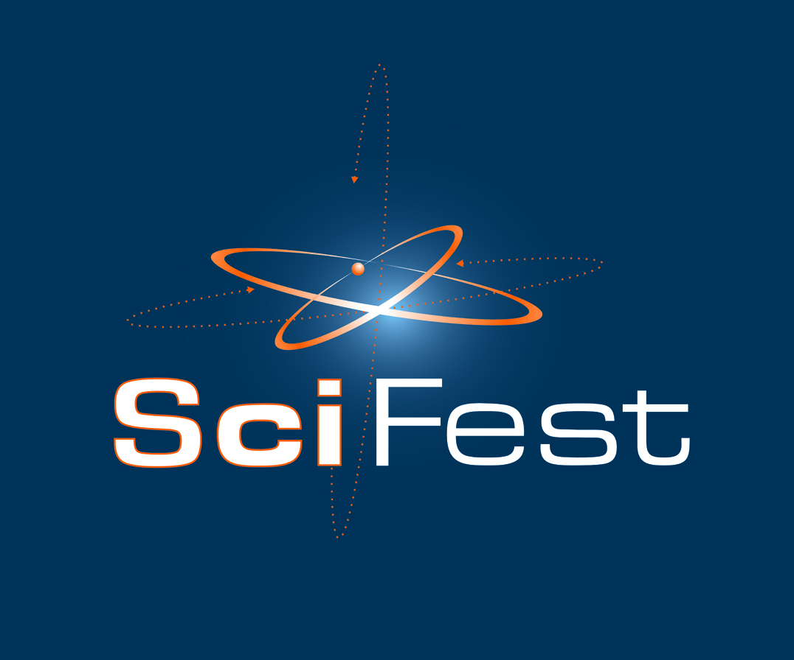 SciFest@DkIT 10th May 2022 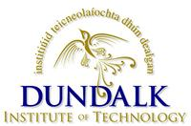

PROGRAMME

8.30 a.m. Arrival, Registration and Set-up in Multipurpose Centre (MPC).

9.45 a.m. Assemble in MPC for Welcome Address and Opening of SciFest 2022 by Dr. Michael Mulvey, President of DkIT

10.00 a.m. Judging of SciFest@DkIT 2022 begins - MPC – (10.00 a.m. – 12 noon)

10.00 a.m. STEM @ DkIT: Information session for teachers - Boardroom DkIT

12 noon Lunch for Competitors, Judges and Teachers (Campus Restaurant)

12.45 p.m. Meeting of Judges (Hospitality Area)

1.00 p.m. Teachers and Competitors assemble for Guest Speakers (Whitaker Theatre)

2.30 p.m. Prize giving ceremony (MPC) by Mr. Paddy Malone, Chair of DkIT Governing Body

3.00 p.m. Removal of Projects from MPC
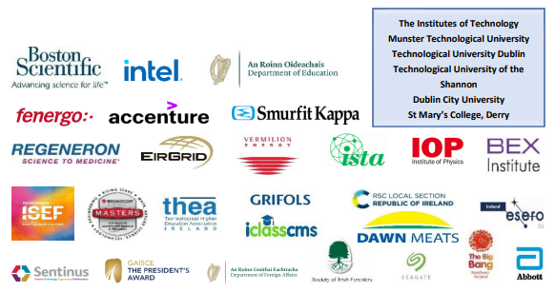

SciFest@DkIT 2022: Prize Categories

- Irish Science Teachers' Association Award (ISTA Student Award)

- ESERO Discover Space Award Student Award

- Discover Space Teacher Award

- Scifest Chemistry Award Student Award

- RSC Chemistry School Award (Royal Society of Chemistry Republic of Ireland Section) School Award – Presented to teacher of project that is awarded the Chemistry Award

- Regeneron Life Sciences Award Student Award

- Accenture Maths in Science Award Student Award

- Fenergo Communications Award Student Award

- Vermilion Energy Innovation Award Student Award

- Smurfit Kappa Sustainability Award Student Award

- Business Excellence Institute Award Student Award

- Institute of Physics Award Student Award

- Intel Technology Award Student Award

- Boston Scientific Medical Devices Award

- Runner-up Best Project Award

- Best Project Award

Other prizes (sponsored by DkIT)

Category
Intermediate | Best Intermediate Life Sciences Project
 | Runner-up Intermediate Life Sciences Project
 | Best Intermediate Physical Science or Technology Project
Junior | Best Junior Physical Sciences or Technology Project
 | Runner-up Physical Sciences or Technology Project



