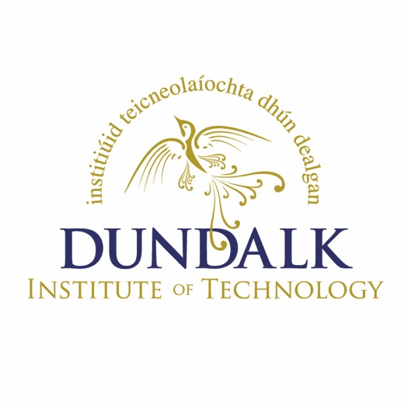 | ERASMUS+ Staff Mobility (NON-TEACHING)  Expression of Interest Form  Dublin Road, Dundalk, Ireland  Tel: 00 353 42 9370355  Fax: 00 353 42 9370351  Web: www.dkit.ie  E-Mail: noreen.carney@dkit.ie

Name:
Functional Area:
Intended Partner College or Enterprise:
Aims and Objectives of applying for a staff mobility:

Expected results:

Have you participated in Erasmus Staff Mobility before? |  |  |  | Yes No
If ‘yes’, when?
Where?

Please return this form to noreen.carney@dkit.ie by Friday, 09th October, 2015.

