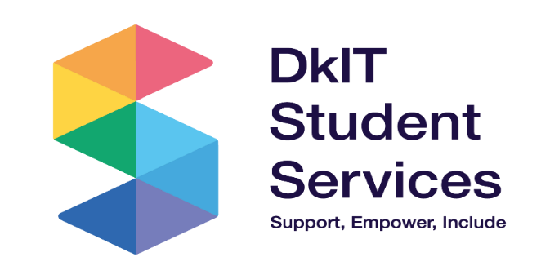  2024/25 | Student Services is a team of professional service providers who provide support for students to actively engage in their third level experience

Student Support Services are provided to full-time and part-time undergraduate, postgraduate, Springboard and Apprentice students. All activities in the area are driven by strategic objectives aligned with the Institute Strategic Plan.

1.0 Strategic Developments and Updates
Achieving our strategic goals for access and progression has led to a growing and increasingly diverse student population. In 2024/25, 27% of our students came from socially disadvantaged areas, reflecting our commitment to widening participation. However, this shift also brings challenges, as financial pressures remain a significant concern—13% of our students reported considering dropping out for financial reasons in the 2023 StudentSurvey.ie, higher than the 11% average across the technological sector. As our campus population grows more diverse with students from underrepresented and disadvantaged backgrounds, our support services are adapting to meet the complex, multifaceted challenges these students face.

Nationally, and in line with emerging research, student engagement is dropping; commuter colleges are increasing; and more students than ever are working full or part time while trying to complete their course. This is placed upon the backdrop of a housing crisis; cost of living increases; restricted travel; and there is much international stress. To strive towards making our campus even more inclusive, safe, and connected, the student counselling service looked to:
- amplify student and staff strengths
- identify trauma within mental health and DkIT more clearly
- enhance the student experience via engaging activities

Our focus is to use our strategic goals to amplify a sense of belonging and connectedness. Three key priorities are noted in DkIT’s support of the student experience:
- Student wellbeing with an emphasis on health, wellness and respect for the diverse needs of students
- Student engagement that can lead to meaningful student and staff collaborations and the development of a culture of partnership
- Support students in becoming self–aware and confident graduates who make meaningful contributions to society
This following summary highlights key developments within Student Services during 2024/25, designed specifically to address the financial and wellbeing challenges faced by our increasingly diverse student population and to foster a more inclusive and supportive campus environment.

1.1 HEA, Programme for Access to Higher Education (PATH)

The Programme for Access to Higher Education (PATH) is a dedicated fund, committed to increasing participation by under-represented groups in higher education. The programme supports the delivery of the National Action Plan Objectives. The following is an update on projects which have been developed over the reporting period in DkIT, to support the priorities of the National Access Plan.

In 2024 /25 DkIT established a Regional Access Forum (RAF) whose membership is comprised of community organisations, FET partners, local second level school personnel, community training centres, TUSLA, Youthreach, DkIT staff and students etc. The aim of the RAF is to work together to build capacity, share knowledge and increase effectiveness around improving access and participation rates from those most disadvantaged. One of the Forum’s first actions was to contribute to the development of the Institute’s new Equal Access and Participation Policy.
As part of our Access programme of works, we contributed to the development of the Certificate in Access to Higher Education, in collaboration with colleagues from the School of Business and Humanities. The aim of this programme is to provide a supported alternative pathway into DkIT for participants from communities and sectors that have traditionally experienced low participation rates in higher education. It is hoped that the programme will be validated in time for its first intake in November 2025.

PATH 4 Phase 1 (2025 – 2026) – Inclusive Environment Fund
In early 2025, an additional round of funding under PATH 4 Phase 1, which centered on measures to foster and enhance belonging in higher education for the most underrepresented groups, was introduced. DkIT were successful in our submission to the fund to directly support students through the provision of additional Assistive Technology hours, Glean licenses and accessible furniture. DkIT have developed a more inclusive campus environment by extending our MazeMap licence and are developing a wellness area to support student well-being and accessibility. Disability awareness training for staff in each of the four academic schools will further promote an inclusive learning environment. This is aligned to Goal 2 of the Strategic Plan 2024-28 which aims to ‘provide accessible and inclusive approaches to Learning, Teaching and Assessment which ensures that all students can flourish and achieve their potential’ (p.32)
The Disability Officer led out on the project to get DkIT accredited as an Autism Friendly HEI. As part of that accreditation in October 2024 the Autism Friendly HEI Working Group developed an Action Plan, implementation of the agreed actions is ongoing.
PATH 4 Phase 5 – Supporting students from Traveller and Roma communities.
DKIT has adopted a multi-pronged approach to attracting students from the Traveller community and increased access rates demonstrate a level of success in this respect. PATH funding has been key to encouraging Travellers to continue in second level education and to consider third level education as a viable option. By working closely with the Meath Traveller Workshop, DkIT provided supplementary educational supports and experiences to a group of young Traveller males at risk of dropping out of the formal education system. Structured visits to the DkIT campus for learners in Youthreach and Community Training Centres are a key outreach initiative. PATH 5 funding is now used to fund a two-day a week Traveller and Roma Outreach Worker post to progress work in this area and to build trust with this community. The Outreach Worker’s efforts have been key to ensuring that Traveller parents and community members have started to attend events on campus (e.g. Parents Information Evenings), has led to individuals enrolling on our Pathways programme (run in conjunction with Louth Local Development LLD), has worked closely with Traveller students in a local second level school and has also been a driver in capacity-building at community organisation level for local Traveller groups.

1.2 National Frameworks
1.2.1 National Framework for Mental Health and Suicide Prevention
The Student Counselling Service is continuing to develop work with colleagues across DkIT and nationally, to support the continued implementation of the three frameworks for student wellbeing which are: Mental Health and Suicide Prevention (MHSP), Healthy Campus (HC), and Ending Sexual Violence and Harassment (ESVH). Counselling has provided initiatives, consultation, and support for each of these. Connection to the national cohort of student mental health services was renewed via membership with PCHEI. This membership facilitated counselling staff training on issues that were trending or emerging within student mental health.

Staff, led by our Mental Health Nurse Advisor (MHNA) developed and progressed the partnership with the JED foundation, which began in January 2024 to improve mental health and reduce rates of suicide. This academic year marked the MHNA’s first full year as part of the Student Health Unit team. Student engagement with the service was encouraging and suggests a continued reduction in stigma surrounding mental health, with more students willing to seek help when needed. A significant portion of the MHNA’s work involves supporting students experiencing ongoing or more complex mental health challenges, further underlining the importance of accessible and responsive services.
Since the site visit by JED in May there have been monthly check ins with the JED representative; the Communications Team were involved in raising awareness through social media, highlighting DkIT’s involvement in the mental health framework and the JED initiative; and there has been regular liaising with the Mental Health committee. Updates have been provided to the Academic Heads Forum, and to the Executive Board, which outlined the action plans, progress including support for students at risk, social connectedness, and leave policies. We have completed the implementation phase of the programme, and now await an assessment, marking the transition into the sustainability phase. Future plans include a post assessment due by November 1, 2025, with an end of year final progress report and review by January 2026.

1.2.2. Making Every Contact Count (MECC) Programme – guided by the HSE MECC Framework
Our Student Health Service continues to promote the HSE "Making Every Contact Count" (MECC) initiative. This proactive approach supports students in making informed, healthy lifestyle choices during a pivotal stage in their lives. It also provides valuable opportunities for our team to discuss related issues such as dietary habits, smoking, and alcohol use—key factors in preventing long-term illness.

1.3 Facilities

Significant enhancements to campus health, wellbeing, and sporting facilities have recently been delivered and approved, further strengthening our commitment to safety, inclusion, and student experience at Dundalk Institute of Techology:
- An outdoor Automated External Defibrillator (AED) near the playing pitches was successfully installed and is accessible 24/7. This important development significantly improves emergency preparedness and represents a vital step in ensuring a timely response to cardiac emergencies, especially during sports and physical activity. The presence of an accessible AED enhances the safety of students, staff, and the wider community, and reflects our ongoing commitment to campus health and safety.
- A new Sensory Room has been installed in the Carrolls Building to accommodate and offer respite to Autistic students and those with Mental Health conditions who study in that building. It will help ensure that students who use the Sensory Room in the Restaurant building have better access to it as it should now have more availability because of the newly created space.
- Approval has been given for the construction of a new sports floor in one of the indoor pitches in DkIT Sport which will enhance the availability of the Faulkner Hall. This project will be included in a capital works tender process and it is hoped to be operational by the end of 2025.

1.4 Changes to Policies and Procedures
The following policies and procedures were introduced/updated during the reporting period:

Equal Access & Participation Policy - This policy, approved by Academic Council in April 2025, is underpinned by the Institute’s Strategic Plan 2024-2028, the National Access Plan 2022-2028 and the Government of Ireland Traveller and Roma Education Strategy 2024-2030. It will assist DkIT in its efforts to meet, and where possible, exceed the targets set in the National Access Plan 2022-2028 and in meeting its commitments under Strategic Pillar 3 Widening Access and Participation of the Institute’s Strategic Plan 2022-2028. The Equal Access policy is particularly concerned with students from groups and communities that are under-represented at third level.

A Disability Policy/Reasonable Accommodation Policy has been drafted and is currently under consultation in advance of submitting to Academic Council for approval. The updated policy will include Reasonable Accommodations in Exams, Use of Glean/Audio Recording Software and Work Placement procedures.

Health Policy and Procedures: Significant time and effort were dedicated to revising, updating, and developing the Health Unit’s policy folder. This work was essential to ensure alignment with the latest national standards and World Health Organization (WHO) guidelines. Each policy underwent a thorough review and was subsequently approved by DkIT’s medical team with necessary amendments made as required. Recent developments have introduced updated recommendations on how to take the oral contraceptive pill. However, these changes have led to some confusion, as current licensing regulations have yet to reflect the new guidance. In response, DkIT Health Unit has developed a clear and accessible patient information leaflet to support students in understanding and safely following the most up-to-date advice.
In September, the Health Unit introduced new opening hours to better accommodate student needs, particularly for fasting blood tests and early appointments before classes. This change has also improved the ability to triage unwell students promptly and provide same-day emergency appointments when necessary.

1.5 Programmatic Review
The School of Health and Science undertook a comprehensive review of its programmes during 2024/25 with support services contributing to the process to ensure a holistic evaluation.

2.0 Student Service Activities and Developments
The following are the key highlights for each of the services for the reporting period.

2.1 Access
The Access Service works to increase access to third level education from under-represented groups, as identified key target groups by the National Access Office of the HEA. The Disability and Student Support Service work to increase the participation of these students in third level with a view to successful completion of the programmes of study.

2.1.1 Student Support
 | The Student Support Office delivers post-entry Access supports, including financial assistance and digital supports, to help remove barriers and enable students to fully engage in their learning experience.

Over the past academic year, Student Support (post-entry Access Supports) have made significant contributions towards achieving the Institutes Strategic Objectives. This has been accomplished through targeted, inclusive, and responsive initiatives designed to enhance student engagement, equity, and success.

Key actions aligned with Strategic Objectives include:
- Access and Participation: Delivered financial supports to socio-economically disadvantaged students, including those students who were deemed eligible under the Higher Education Access Route (HEAR) and other priority cohorts.

- Student Success: Provided one-to-one and small group support through an open-door policy, ensuring timely and accessible interventions.

- Digital Equity: Managed the Lapsafe system and the Laptop Loan Initiative to ensure students had access to essential digital resources.

- Operational Efficiency: Continuously reviewed and improved application processes, documentation requirements, and reporting mechanisms.

Throughout the 2024-2025 academic year, this newly developed role made significant strides in the provision, development and enhancement of post-entry access supports. Growth has been informed by student needs, staff feedback and institutional priorities.

Specialised Student Supports

- Continued delivery of a hybrid support model (walk-in and appointments), enabling responsive, student-centred engagement and timely intervention in cases of personal, financial, or digital hardship.
- Launched a dedicated student support email, significantly improving communication, query tracking, and service signposting, ensuring timely referrals to appropriate services and supports.
- Hosted targeted student engagement events for underrepresented groups, including Financial Support Talks for HEAR eligible students.
- Mature Student Pre-Induction Orientation - A tailored pre-induction orientation session was delivered to incoming mature students. The session included a 45-minute presentation on available supports followed by a campus tour.

Financial Supports

Student Assistance Fund (SAF): A full review of the SAF process led to several key enhancements:

- Simplified Application Process: The application process temporarily shifted from online to paper-based, allowing for greater oversight and a clearer understanding of student challenges. The revised application was shorter, clearer, and required fewer supporting documents.

- A structured payment management system was implemented in Term 2, improving efficiency and tracking.

- The points-based assessment framework was refined to increase transparency and consistency while retaining flexibility for exceptional cases.

- Plans are in place to introduce a more nuanced scoring system to better support “middle income” applicants.

1916 Bursary (PATH 2)

- Ongoing support was provided to awardees, including assistance with transitions to postgraduate studies at DkIT and other HEI’s.
- Promoted through email, poster campaigns and in-person workshops, generating strong awareness and interest.
- One-to one application support sessions were introduced for prospective applicants.

Bernard Dufy Scholarship

- Two scholarships successfully awarded again this year.

Student Accommodation Assistance Fund

- One student was successful in their application with their accommodation being covered for the entire academic year.

Provision of Digital Resources

- Continued successful management of the Lapsafe self-service kiosk, ensuring 24-hour laptop loans - a vital resource for many students.
- The Laptop Loan Initiative remained in high demand and was efficiently delivered to socio-economically disadvantaged students and students with a Disability outside of the Fund for Students with a Disability Funding Model.
- Two phone charging units were installed.

2.1.2 Disability Service

 | The Disability Service provides support to students with a disability, significant ongoing illness or mental health condition who disclose to the service and request support

DkIT is committed to providing an equitable learning environment for all students (Full Time, Part Time, Post Graduate and Apprentices). Since 2018 DkIT has been supporting students who apply through the Disability Access Route to Education (DARE) scheme thus enabling those students who meet the criteria to avail of reduced points places on courses in DkIT. The Disability Service (DS) provides a wide range of supports and reasonable accommodations for students with disabilities. The Service supports students with physical, sensory, learning or mental health disabilities through a variety of supports offered, these include but are not limited to:

- Advocacy
- Note Takers (Human and Electronic)
- Personal Assistants
- One to one Learning Support Tutors
- Extended Library Loans
- Access to Sensory Rooms
- Access to Assistive Technology (AT) equipment, training and room.
- Reasonable Accommodations (RA) in Examinations

Pre-Induction Orientation

In September 2024 Pre-Induction Orientation sessions were introduced for two student cohorts:

- All those who declared a Disability on their CAO application
- Those who had an Autism diagnosis
The sessions were approximately 2 hours in duration and provided information on what to expect during Induction, an opportunity to meet fellow classmates, get their student ID Card in a quieter setting and a tour of the area they would be studying in. Staff of Student Services were briefly introduced to the groups. This was extremely beneficial to new students; some of whom attended with parents and helped them be more engaging and less anxious about the start of their 3rd level experience.

Autism Festival of Acceptance
This was the 2nd year that DKIT, together with colleagues in NCI, DCU ATU Sligo, NCAD, CCT College, took part in the annual Autism Festival of Acceptance which is a series of events aimed at promoting acceptance and understanding of autism. The events were designed to raise awareness, provide resources and foster a more inclusive environment for individuals with autism. It ran from 24 – 27th March and involved various events and activities across different participating HEIs. One session was hosted by one of DkIT’s Library staff as the theme was around Library spaces. There was an increase in attendance for most of the session on last year. The Events were online and were also attended by some staff.

The table below details the numbers of students registered with the Service including the range of disabilities. There has been an increase in some disabilities and the decrease in others. Specific Learning Difficulty continues to be the most common disability among students seeking support. The increase in ASD and the reduction in Mental Health numbers may be a result of more confirmed diagnoses of Autism instead of MH as the number of new 1st years with MH was only 1 student yet the number of students with MH condition as a secondary disability was 21.

Breakdown of Types of Disability Supported  (UG and PG, PT and FT) – Primary Disability | 24/25 | 23/24 | 22/23 | 21/22 | 20/21 | 19/20
ADD/ADHD | 24 | 19 | 25 | 19 | 12 | 6
Autism Spectrum Disorder  (Including Asperger's Syndrome) | 61 | 47 | 27 | 32 | 23 | 22
Blind/Visual Imp | 10 | 4 | 3 | 4 | 3 | 3
Deaf/Hearing | 5 | 5 | 5 | 4 | 4 | 4
Developmental Co-ordination Disorder (DCD) Dyspraxia | 35 | 33 | 29 | 31 | 33 | 26
Mental Health Condition | 19 | 34 | 24 | 22 | 28 | 24
Neurological Condition including Speech and Language Difficulties | 21 | 22 | 24 | 22 | 20 | 14
Physical Disability | 12 | 12 | 12 | 14 | 13 | 16
Significant On-going Illness | 25 | 24 | 20 | 25 | 31 | 33
Specific Learning Difficulty | 148 | 116 | 129 | 120 | 107 | 111
Other incl. General / Mild / Borderline Learning Difficulty | 46 | 5 | 4 | 7 | - | -
Totals | 406 | 321 | 302 | 300 | 274 | 261

For 2024-25 there were 187 students had two or more confirmed disabilities/conditions.

There has been in increase in Apprentices on Campus with 384 overall. This has resulted in an increase in the numbers registering for support from the DS.

Breakdown of Types of Disability Supported  (UG and PG) – Primary Disability | 2024-25  Intake 1 September | 2024-25  Intake 2 January | 2024-25  Intake 3- April
ADD/ADHD |  | 1 | 3
Autism Spectrum Disorder (Including Asperger's Syndrome) |  |  | 1
Blind/Visual Imp |  | 1 | 1
Deaf/Hearing |  | 1
Developmental Co-ordination Disorder (DCD) Dyspraxia |  |  | 1
Mental Health Condition |  |  | 1
Neurological Condition including Speech  and Language Difficulty |  | 1
Physical Disability |  |  | 1
Specific Learning Difficulty | 6 | 14 | 9
Other incl. General / Mild / Borderline Learning Difficulty/Literacy Difficulties with no dx -SOLAS screening | 13 | 10 | 12
Totals | 19 | 28 | 29
Of the total over the three intakes, 12 apprentices had two or more difficulties.

The following are some of the other key highlights for the service this year:
- Liaising more closely with Mental Health Nurse to provide support to students who register with the DS who have MH Conditions.

- The ongoing availability of an Assistive Technology (AT) Officer provides training to support students who have literacy difficulties and all AT queries.

- The DS continues to provide information to new Invigilators and Scribes during their training. These sessions help invigilators and scribes understand the specific guidelines and regulations for supporting students with disabilities during exams, helping to maintain fairness and compliance. It also ensures that reasonable accommodations are implemented correctly, issues are addressed proactively, and the process of invigilation runs smoothly and imparts confidence in students and invigilators.

- The MSForm for students who request supports in RA in Exams in In-Class tests has been updated to include a question to encourage students to engage with their lecturer before requesting supports, this update is as a result in the over/miss-use of the form and the fact that some students’ lecturers can accommodate the RA in in-class tests at a local level and not all in-class tests require reasonable accommodations such as MCQ tests for example, without input from the DS and Exams to provide the support.

- Ongoing updates and maintenance of website, Autism&Uni website and the student Moodle support hub. A specific Staff section on the Moodle hub includes information about supporting many disabilities and RA in Exams and Marking guidelines. It is hoped to include links to AHEAD ARK training resources on the Moodle page for Staff.

2.2 Student Counselling Service
 | The Counselling service is free and confidential for students. The service is operated by a team of psychologists and counsellors who are fully trained and accredited.

This section outlines some of the key achievements and initiatives within the Student Counselling Service during the year 2024 – 2025 along with some learning points and plans for next steps.

The focus of the last academic year was the stability and clear running of clinical services regarding student mental health. The Counselling Service has seen significant change over the last reporting period. The Head of Counselling left DkIT in July 2024, and the new head began in February 2025. The team continued to provide counselling throughout the academic year; a new clinician began in September 2024; and the recruitment of a permanent post has been achieved. Additional services have continued such as Togetherall, NiteLine, Textaboutit (50808) and the new drop-in service. The drop-in service which was introduced last year has benefited students and has also supported staff in signposting to this service. This has been received well and is now adopted to continue throughout the academic year.

As part of PSI/IACP guidelines for best practice, student counsellors continued to engage in monthly external supervision. Weekly team meetings continued, with the aim to review business matters or any cases they wish to explore as urgent. The Mental Health Nurse was also brought into case discussion on a regular basis.

Counselling have continued to advertise the Responding to Students In Distress or at Risk (RSIDR) training to staff with school-specific invitations pending in advance of the new academic term. This work builds on the previous online Supporting Students as Staff resources developed by Counselling.

Data Management
As part of maintaining the service, the Corenet (CORE-IMS) Client Management System (CMS) was renewed. Regarding outcomes: Counselling agreed to include further encouragement to students to complete measures at end of therapy instead of after, to increase form completion. Counselling also took part in the Psychological Counsellors in Higher Education in Ireland (PCHEI)-wide anonymised data collection, staffing analysis, and projects that updated the Higher Education Authority (HEA) on data regarding Mental Health and Suicide Prevention (MHSP) and Healthy Campus (HC). The team discussed best practice and referral processes between departments and local teams. In line with MHSP feedback, future data will be collected on additional non-direct and advocacy work outside of clinical intervention and events.

The service continues to use CORE-IMS as the CMS. This allows for data collection and collation regarding key aspects of service delivery including service outcomes and evaluation. The data below relates to the period 1st September 2024 to 31st May 2025:
During the reporting period, 311 students registered with the student counselling service. This is a small reduction in registration figures in comparison with recent years which is consistent with national engagement statistics and curve regarding the pandemic, however in the last year Counselling had fewer clinicians. See table below:
Numbers attending
2020/21 | 2021/22 | 2022/23 | 2023/24 | 2024/25
312 | 451 | 410 | 341 | 311

Key highlights below regarding student data show that almost 1 in 5 students attend who have a disability; the students from the School of Informatics and Creative Arts are the cohort who attend mostly; the presenting issue of anxiety remains as a top concern; and almost 1 in 10 attend due to issues of abuse. Students who stated details upon registration are as follows:
Gender
- 44% identified as female
- 28% identified as male
- 2% identified as transgender/non-binary
Background
- Registered with Disability Office: 18% (3% of registrations were for an enduring mental health issue)
- International: 15%
- Mature: 17%
- Registered under DARE: 6%
- Registered under HEAR: 3%
- In receipt of SUSI: 40%
Academic
- Postgraduate: 5%
- Access/Apprentices: 3.5%
- Creative Arts and Informatics: 38%
- Business and Humanities: 32%
- Health and Science: 19%
- Engineering:11%

Appointments
We offered a total of 1,301 appointments for assessment and counselling sessions this year, which was a small reduction to the previous year (1,434) and congruent with a reduction in staff. These appointments include 63 students attending the drop-in appointments. November remained the busiest for both assessment and counselling appointments.

Presenting Issues
Top 5 issues presenting to counselling were:
- Anxiety
Experiences of excessive fear/anxiety, including social anxiety, worry, panic, stress, obsessive or intrusive thoughts, phobia, post-traumatic stress, etc.

- Relationships
Interpersonal difficulties such as distress in friendship or family relationships, relationship with housemates/classmates, supervisors, break-up of romantic relationships or romantic rejection, difficulty starting/building connections with others, loneliness, or isolation, etc.

- Identity
Issues related to a client’s view of themselves or how they are viewed by society, including difficulties with self-esteem and confidence, self-criticism, perfectionism, gender identity and expression, racial / ethnic / cultural identity, negative body image, etc.

- Depression (+ anger and mood change)
Experiences of low mood, mood swings, emotional numbness, feelings of hopelessness, irritability and anger.

- Academic issues
Issues with performance and participation in a client’s academic occupation. Includes course choice, exam failure, issues with motivation, managing workload, placement issues, plagiarism, procrastination, academic discipline issues. Also includes negative impacts on academic performance by other presenting issues.

Risk issues
Data showed that some students were at risk (ranging from ‘mild to severe’) at the point of assessment. Students who were deemed to be at imminent risk, received specialist care via the CAMS intervention (Collaborative Assessment and Management of Suicidality). Risk details are as follows:
- Risk of suicide: 3.5%
- Risk of self-harm: 6%
- Number of students engaged with suicide intervention and safety plan: 5.
- Fewer students were deemed at risk of suicide this year in comparison to last year.

Data also showed that 8% of students attending counselling had experienced abuse and was the key reason for attending. Abuse includes a historic or current experience of physical, emotional, sexual, domestic, or online abuse and/or neglect. This also includes bullying, harassment, discrimination, and other crimes against the client. This category includes trauma broadly.

Key actions required for future improvements:
- There is a need for more efficient data management. To date, research into advanced CMS has shown the benefits of moving to a new system for counselling records. This renewal is due in March 2026.
- Using PCHEI’s new template which focuses on pillars within the Comprehensive Counselling Model allows all HEIs to display their activities effectively on a local and national level. These pillars are: Clinical Services (Providing direct counselling and crisis support for students); Consultation & Collaboration (Working with staff, faculty, and external services); Mental Health Promotion & Prevention (Running workshops, training, and awareness programs); Training & Education (Educating staff and student leaders on mental health); Research & Development (Using research to improve services and policies).
- The Collegiate Center for Mental Health has been providing a Clinical Load Index (CLI) in recent years, however services can be improved by the upcoming benchmarking via an Irish-specific CLI. This supports services in determining output per clinician.
- Many staff have completed the RSIDR training, however there is an opportunity for staff to develop further non-clinical skills which will support DKIT in becoming a Trauma Aware college. This would be part of a broader project between PCHEI and Active*Consent, with the view for DKIT piloting the initiative.
- Renewed efforts to signpost out of hours supports, including advertising the new improvements made by Spunout and Togetherall e.g., Navigator and Peer training.
- Additional resources and signposting to be made available for Apprentices throughout their time at DkIT, with further collaboration from the Students’ Union (SU).

Mental Health Week
The team ran a mental health week, aligning with World Mental Health Day (10th October) in partnership with other teams from student services and the SU. This week-long event consisted of many activities, workshops and talks, which included onsite supports and fun activities for both students and staff. Events included:
- talk on stress management
- mobile animal farm
- yoga
- music for mental health event
- support stands
- coaching skills
- breathwork
- meet the counselling team
- wellbeing talks
- coping skills e.g. journaling, breathwork, mindfulness.
- drumming circle
- forest hike

Internal and External Collaborations
Counselling collaborated with several departments and showed support for academic and meaningful initiatives:
- The team collaborated with wider student supports to focus on wellbeing for the Health Fair. Experiential exercises were provided to students on mood (Feelings tree with paint) and psych-education about dopamine (helpful activity ideas for mental health). The Heath event also included a guest speaker on overcoming addiction and mental health challenges.
- Counselling and Pastoral Care provided a support seminar on bereavement to students after the death of their classmate.
- Counselling presented information about counselling services to staff and departments from each school, as well at the Academic Heads Forum.
- Taster sessions and training was provided to prospective students for the Respect and Support Champions (pilot project).
- A stress management workshop was held before exams and end of year assignments with Pastoral Care.
- Supported students as participants in their research projects regarding wellbeing.

Counselling was involved in many projects over the last year that span nationally, cross-border, internationally, and covers best practice, research, and strategy:
- Part of a transatlantic event between American, UK, and Irish counselling services. Staff were part of a panel discussing current affairs, trends, and issues with the mental health crisis narrative.

- Partnership with The JED Foundation, working on becoming an accredited organisation with them to enhance suicide prevention.

- Continued to be part of the PCHEI+HSE collaboration on training and provision of Emotion Regulation groups to students (DBT informed).

- Involved in a national video release, publicising the HC charter.

- Involved in a pilot projects with PCHEI and Active Consent to focus on building Trauma Aware HEIs.

- Counselling met with UU with the view to collaborating on a shared creative project in the coming year.

- Counselling staff took part in the U-Well project, research run by ATU and UU, seeking to conduct a series of workshops and a survey to better understand the facilitators and barriers to rolling out a survey on student mental health for incoming first year students on a national level.

- Counselling staff are part of SMART-IE (Student Mental heAlth Technologies - Implementation & Evaluation), which is a Health Research Board-funded initiative led by University of Galway. The focus in on understanding the implementation of online mental health support platforms. This project specifically uses Togetherall as a case study to explore the implementation of such projects within university systems.

Counselling has ongoing and new membership on several working groups:
- Care & Respect (oversight on MHSP, HC, ESVH)
- MHSP
- HC
- ESVH
- MH subgroup of HC
- Campus Watch
- Green Campus

Key highlights from these groups are:
- The counselling team continue to lead the student mental health working group. This year, key recommended actions from the HEA framework were maintained and the working group membership has been expanded in line with this to ensure key elements from the Institute are represented.

- Staff are part of the HEA Wellbeing Advisory Group which oversees MHSP and HC nationally.

- The team as part of HC has links with Healthy Louth.

- The team was involved in supporting and handing over the ESVH mantle to the new HEI role of ESVH Response Manager. This is a dedicated service to ESVH which manages the training, awareness campaigns, and advocacy work, which may be supported by counselling as needed.

- Counselling provides training of Support and Respect Champions, a group of student peers who are interested in MHSP and ESVH.

Togetherall
Counselling continues to partner with Togetherall, a service which offers students access to an anonymised online space where students can talk, share, support and be supported by peers. It also provides mental health screeners, structured self-help courses, and has a large clinically trained team of mental health professionals who moderate the site 24/7. The service has been advertised in counselling, email sign-offs, campus posters, and a new reminder to be installed in the Moodle sidebar at 4 key stress points throughout the next academic year. See evaluation in section 4 below.

NiteLine
Counselling continues to partner with NiteLine to offer an out-of-hours support service to students. Niteline is a call and instant message helpline service offered to students by students from 9 pm until 2.30 am every night during term time. Volunteers are trained and offered support by staff from counselling services across the country. See evaluation in section 4 below.

Text About It (50808)
Counselling continues to partner with Spunout’s Text About It service. Is a free, anonymous, 24/7 messaging service, providing everything from a calming chat to immediate support for mental health and wellbeing. At the end of the academic year, Spunout launched their Navigator program which Counselling aim to advertise from the new semester onwards. Key features include:

- A simple 3-step guided journey that delivers immediate, personalised results.
- A mobile-first design (but also accessible on desktop).
- Curated mental health information, videos, and sharing of peer experiences.
- Recommendations for expert-approved podcasts, books and mobile apps.
- Signposting to local and national mental health services.
- Ability to bookmark your ‘favourite’ content and save it for later.
- Privacy-first infrastructure supporting anonymous use and data insights, with no login or sign up.

2.3 Pastoral Care
 | Pastoral Care is about welcome and working collaboratively in the provision of holistic care within the College community.

This academic year saw a surge in students accessing the Pastoral Care Service for numerous issues ranging from financial and academic struggles to mental health concerns and stress. The hardship fund and pantry were set up to help deal with some of the extreme financial challenges facing students. Well-being workshops and outdoor events were provided to encourage taking breaks, exercise and the power of breath to regulate the nervous system. The Pastoral Care Service has grown and evolved. The visibility of the Pastoral Care Service is important moving forward and it has potential to evolve into a team due to the increasing demands of students.

The following are some of the highlights for the Service:

New Interfaith Space
Our new Interfaith Space for all faiths and none was launched in September. The door was fitted with a card lock requiring students to register their student cards to access the room. The room was enhanced to allow for prayer and quiet reflection. There was good feedback from the students who were accessing the space. It replaced the temporary makeshift space which was previously located in the Old College Bar.

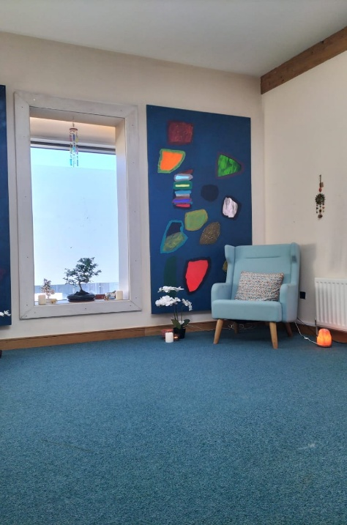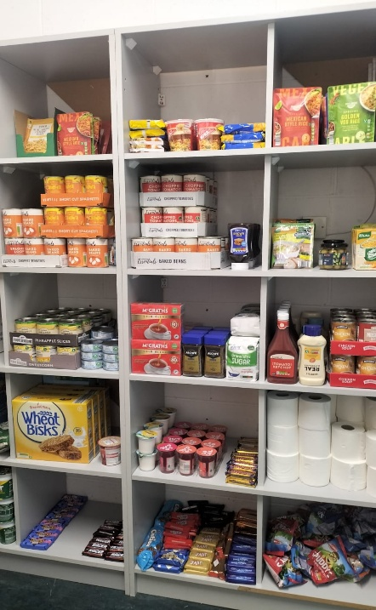

New Pantry
The Food Press previously located in F211 was upgraded to The Pantry and relocated to the storage area opposite the Students Union. The Pantry provides nonperishable food and hygiene items to students who are facing financial difficulties. This offers more space and can store a greater amount of stock which is currently funded through fundraising and donations.

Fundraising
Bake sale Student Hardship Fund
A fundraiser for the student hardship fund was organised with the help of members of Student Services and Students Union. Fresh bakes and tea and coffee were offered for a small donation. One4all vouchers were also raffled. Collectively a total of €556.45 was raised for the student hardship fund.

Daffodil Day fundraiser
Funds were raised for daffodil day raising money for the Irish cancer society. Daffodil pins were sold to students and staff, and a raffle held with the prize being a signed Ulster Jersey. A total of €450 was raised for this very worthy cause.

Charity Sea Swim with 4th Year Mental Health Students
Pastoral Care Coordinator was delighted to be invited by the students to take part in a charity swim in Carlingford Lough in aid of the Dundalk Counselling Service. Over 20 brave souls entered the freezing sea to raise money.
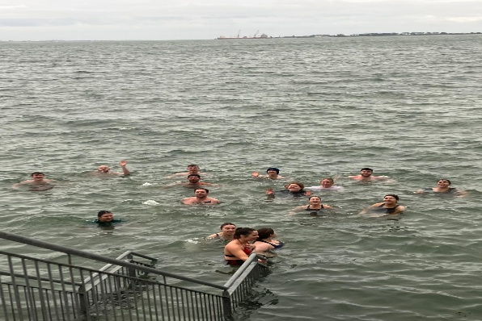

Pancake Tuesday
The now famous DkIT Pancake Tuesday returned to campus this year. With the help of student services staff over 300 pancakes were served to staff and students who had their choice of delicious toppings. This year pancakes were handed out for free as a goodwill gesture.
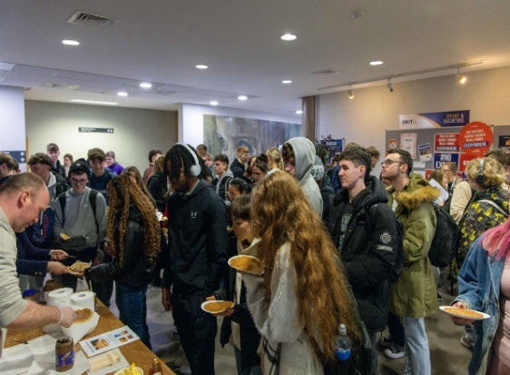
Workshops
Breathwork Classes - As part of Mental Health and Wellbeing week, a class was offered and attended by students and staff highlighting the importance of using your own breath to reduce stress and anxiety. These classes offer students and staff an opportunity to take a break from study and work to check in and rebalance their nervous system.
Tribal Drumming – a tribal workshop returned to DkIT, as part of Mental Health and Wellbeing week. This was a two-hour workshop where students and staff got to learn about the power of rhythm using traditional African drums. This was a fantastic success with well over 60 students and staff in attendance. Feedback was brilliant from everyone, and it created a real buzz on campus.

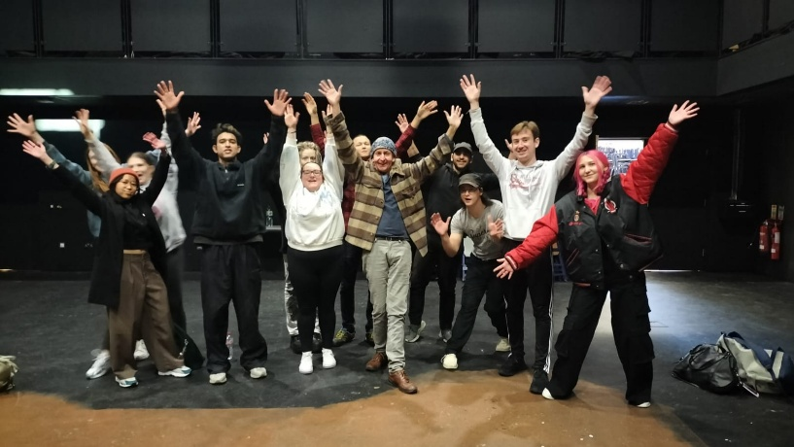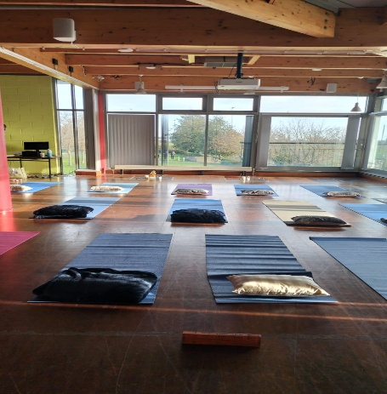

Positive Masculinity Workshop - Cormac Noonan returned to campus again to facilitate a workshop on Positive Masculinity which was well attended. Wellbeing and mental health specifically for the male population is an area that needs focus and by providing this platform, so men feel safe and comfortable to be open and vulnerable is invaluable. While we did not reach the same numbers as last year, those who did attend found it incredibly powerful. It highlighted the desire for male students to have more targeted events like this.

Let’s Talk Stress- A workshop for all students centered on Stress. What it is, how to recognise it and ways to manage it. This was presented in an informal way to encourage interaction and conversation from students. This was an excellent workshop which was well attended. It helped deal with the common issue facing students which is largely stress. Pizza and refreshments were provided to all students in attendance.

Lunchtime Walk and Talk - When the weather improved, some walk and talk lunches for staff and students took place. Soup vouchers were purchased by the Service from the DkIT Canteen for every person who attended and completed the walk. These events encouraged exercise, mindfulness and making connections.

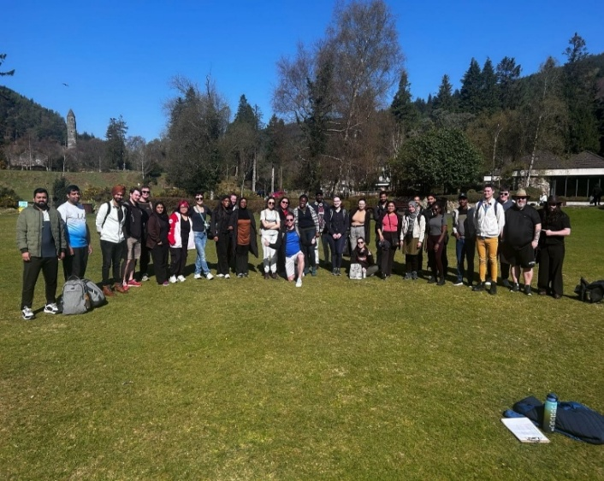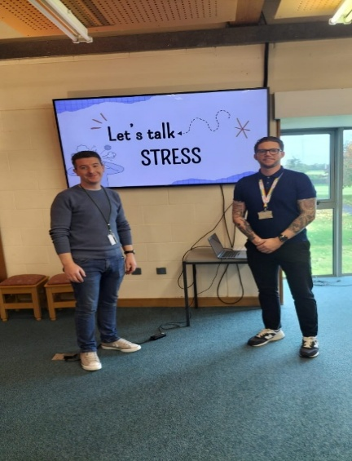

Day Trips
During Mental Health and Wellbeing week, on a beautiful bright day on October 11th , students took part in a guided hike of 8.5 km around Ravensdale Forest. Students thoroughly enjoyed the hike and more importantly the views.
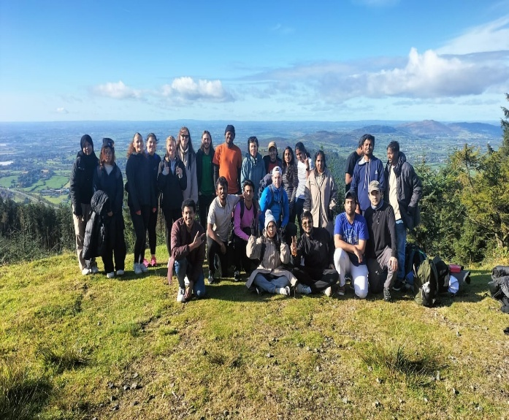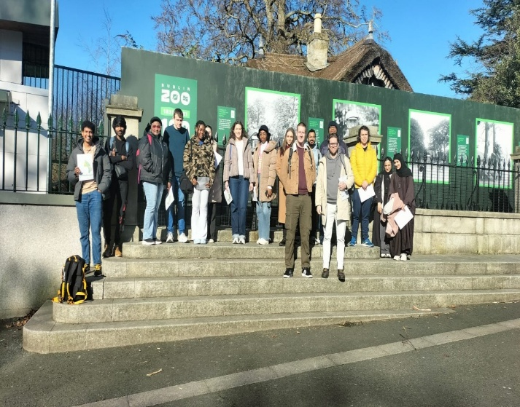
Approximately 24 students came together for a trip to visit the neolithic site of Newgrange. Students were allocated time for a guided tour inside the famous chamber of Newgrange. Great feedback was received from the students on a thoroughly enjoyable trip.

Students got the opportunity to visit Dublin Zoo as Pastoral Care arranged a trip which around 20 students attended. They could explore the Zoo at their own leisurely pace aided by a map they received upon entry. It was a beautiful day, and the students really enjoyed the day out.

Over 30 students went on a day trip to Glendalough National Park on what was a beautiful day. Students had the opportunity to explore the park at their own leisure before arriving at Johnnie Fox’s bar and restaurant for a delicious meal and a refreshing drink. This was an excellent day and great feedback from the students who really appreciated it.

2.4 Student Health Unit
 | Student Health Unit provides a general medical, psychological and health educational service to all students in a confidential, professional & courteous manner. The centre includes free nursing care and access to a doctor at scheduled times throughout the week.

The Student Health Unit (SHU) team remains dedicated to enhancing the quality-of-service delivery. Our work continues to focus strongly on promoting health and wellbeing and supporting positive mental health across the student body. However, we recognise that this remains an ongoing challenge, particularly considering the steady increase in students seeking support and the growing complexity of the issues they are facing.
Service Statistics:
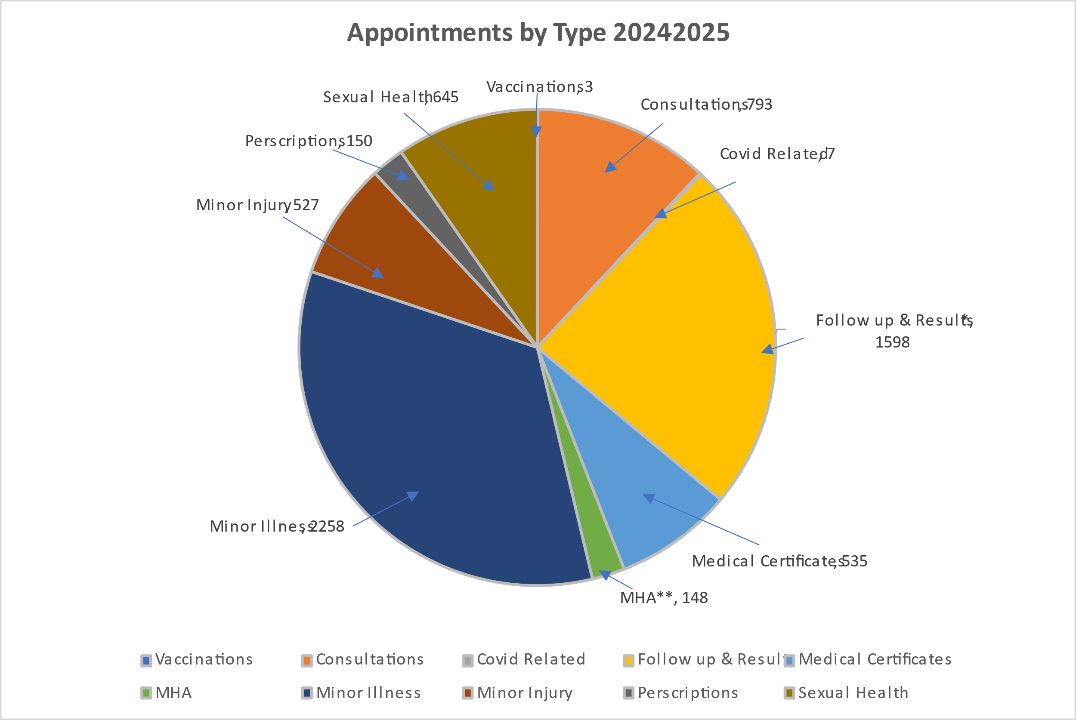
Total numbers July 2024 - May 2025 = 6664
* Follow-up: Monitor patient symptoms when unwell or injured, reinforce care knowledge and action plans, laboratory test results following all testing in SHU.
** MHA: Mental Health Advisor

Our HPM software indicates a significant increase in overall service activity during the year from 5,417 in the 2023/24 academic year to 6,664 in 2024/25 — representing a 23% increase. This significant rise suggests improved awareness and/or access to health services among students. Minor illness continues to be the most common reason for appointments. Approximately 72% of attendance was by international students (acknowledging the potential inaccuracy due to administrative disruptions).
Service Activities and Developments
Sexual Health Services:
Among various initiatives, the SHU is particularly proud of its sexual health promotion and screening and the positive outcomes achieved:
While data suggests a slight decrease in overall sexual health testing activity, a notable decline was observed in the positivity rate—a positive indicator of student health. One key development was an increase in male students accessing sexual health services, a welcome and important trend. 2024/2025 data continued to reflect strong engagement with sexual health services, with 89.4% of booked appointments attended. The gender distribution among attendees was evenly split, with 50% identifying as female and 50% as male—an encouraging shift from previous years where female students were significantly more likely to access the service. The overall positivity rate stood at 15.8%, showing a slight decrease from the previous academic year. Among those who tested positive, chlamydia remained the most detected infection, accounting for 41.7% of cases. Gonorrhoea made up 16.7%, while genital warts were identified in 33.3% of positive cases. Herpes Simplex Virus (HSV) was the least common, representing 8.3% of the total. Chlamydia continues to be the most common sexually transmitted infection among the student population, mirroring national trends.
2024/2025 STI stats:
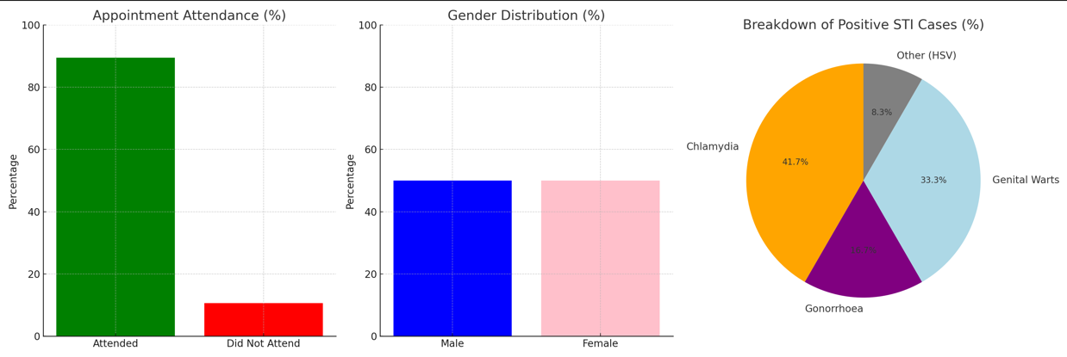
Compared to the same period last year, the SHU saw a 13.6% reduction in testing activity this year. While the exact cause of this decline is not fully clear, it is worth noting that the SHU experienced several internal administrative staff changes during this period. A transition in administrative staff meant that multiple new team members required in-house training. As a result, key activities such as health promotion had to be scaled back at times, whereas in previous years, these efforts were more consistently prioritised and visible.

Health Fair
Following careful consideration, the decision to change the event venue and reschedule it to March was made. Although the timing coincided with exam week for many of the apprentice students, something less than ideal, the change was necessary due to adjustments in administrative support within the SHU. Despite this, the event proved to be highly successful. Student engagement on the day was exceptionally high and marked one of the most well-received events to date. It was especially wonderful to have so many incredibly talented DKIT students involved in organising the event this year. As always, the collaboration with the wider student services colleagues, particularly the Sports and Societies teams, the Counselling Service, the Pastoral Care Coordinator, the Student Union, staff from the School of Nursing, Nutrition, Hospitality, Sports and Exercise, and Event Management departments - was key. The SHU is very grateful for the support of external partners the HSE and An Garda Síochána. Mark from the HSE Quit Team and Olivia from the Health Promotion Department were welcomed participants to the fair. Both provided expert advice on a wide range of health promotion topics, with a particular focus on issues relevant to the student cohort. The event wrapped up with a powerful talk by Mary Hulgraine, who shared her inspiring journey of overcoming addiction and mental health challenges.

Health Campus Committee
The SHU are actively involved with the Healthy Campus Steering Committee, supporting initiatives that promote mental and physical wellbeing, sustainability, and a positive campus culture. This collaborative approach remains vital to creating a healthier and more inclusive college environment.

Vaccination Clinics:
Due to limited administrative support the usual annual flu and COVID-19 vaccination clinics for students and staff did not run. These clinics require substantial administrative coordination.
MMR Pop-Up Clinic:
In September 2024, the Health Unit hosted the HSE on campus to deliver a pop-up MMR vaccination clinic following a rise in measles cases across Europe.

SHAG Week Activities HIV Ireland:
HIV Ireland once again provided rapid HIV testing as part of SHAG Week in February, along with sexual health education and advice. Stephen and his team were highly complementary of the engagement from students and expressed appreciation for the warm welcome they consistently receive.

Substance Misuse Awareness
Garda Darragh attended the Health Fair to deliver an informative session on drug misuse focused on increasing awareness of the impact of substance abuse on individuals, families, and the wider community.

Road Safety Awareness
The RSA Shuttle Bus attended campus, offering students an interactive and educational experience focused on road safety. The initiative was well-received, with students also given the opportunity to engage in using the road safety VR goggle simulations that reinforced the importance of safe driving habits. This collaborative effort helped foster greater awareness around responsible road use among the student community.

The Light Up Your Bike campaign on campus was supported by the SHU and aimed at promoting cyclist safety during the darker months. This collaborative initiative, run in partnership with Louth County Council, An Garda Síochána and the Road Safety Authority - highlighted the importance of visibility for cyclists, particularly during shorter daylight hours. Free bicycle lights and high-visibility items were distributed at the Hoey’s Lane entrance to DkIT in November. The event received strong student engagement and was also promoted across social media channels. It was particularly welcome to see Dr. Sean Owens from the Clermont Health team in attendance, reinforcing the connection between road safety and overall student wellbeing.
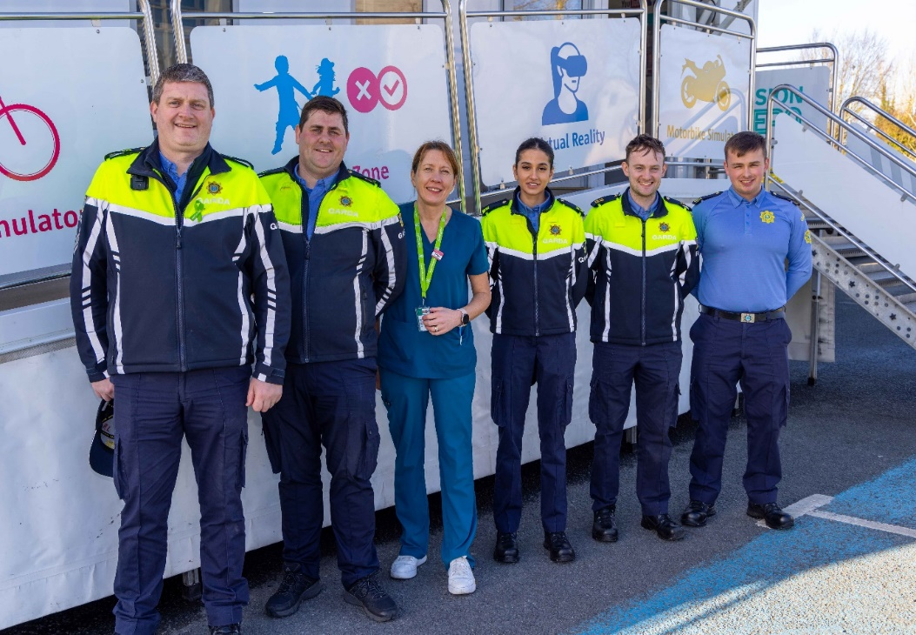

Service activities for the Mental Health Nurse Advisor (MHNA)
The academic year has been a busy period, with a high number of students seeking mental health support, an encouraging sign of reduced stigma and increased openness to help-seeking. Much of the work involved supporting students with ongoing or complex mental health needs, including close collaboration with GPs, community mental health teams, and specialist services to ensure continuity of care. Challenges arose in supporting international students particularly those already under care in their home countries, requiring cross-border coordination with overseas consultants, often navigating different prescribing practices and healthcare systems. Common issues included anxiety, low mood, and depression, while growing numbers of students sought understanding around neurodiversity, particularly in relation to focus, executive functioning, and sensory sensitivity. Social isolation, loneliness, financial stress, especially among international students - and emerging concerns around AI, job security, and the future also featured prominently. A big positive for the Mental Health Nurse this year was the strong collaboration with Student Health, Student Counselling and Disability services. The shared approach and ongoing communication across services is worthwhile and appreciated. Working collaboratively meant students got more coordinated support, which made a huge difference for many.

2.5 Sports and Societies
 | The Sports & Societies Office runs over 65+ student-led clubs and societies so whether students want to pursue an existing interest or try something completely new, there is something for everyone.

Service Activities and Developments:
In September, the Sports and Societies Officer launched the #TryItAll initiative, aimed at encouraging female students to engage more actively in sports and physical activities. The initiative was supported by N-TUTORR. The #TryItAll campaign was designed to break down barriers and promote inclusivity in sports among young women at DkIT. By offering a variety of activities—ranging from traditional team sports to innovative fitness programmes—#TryItAll ensured that every student regardless of skill level or experience, could find an activity that suited them. Over 40 students took part in the sessions which included soccer, GAA, rugby, basketball, badminton, volleyball, dance and team building activities.

To launch the initiative, an event was held on the DkIT campus, featuring an inspiring keynote address by Olympian Kate O’Connor, whose achievements on the international stage have made her a role model for many young athletes, delivered a powerful speech highlighting the transformative power of sports. Kate shared her personal journey and emphasised the importance of sports participation in building confidence and leadership skills.

On April 7th, 150 secondary school girls attended DkIT to contest the inaugural Sonia Hoey Cup. The event marked the culmination of an 9-week School Development Programme, part of the ongoing Female Athlete Health and Wellbeing programme launched by DkIT and Louth LGFA earlier this year.

An Appeals process was introduced as part of the Sports Scholarship Programme. Appeals will now be reviewed by a panel comprising two independent staff members who were not involved in the original selection process. The purpose of the appeal is to ensure that procedures are followed fairly and consistently.

Once again, sports and societies held training for committee members to assist and support them in the running of a society and to ensure the society doesn’t end when key members graduate.

The Gaelic Players Association (GPA) held drop-in sessions on campus and held individual appointments with county players at DkIT to inform them of the additional financial and career support they can avail of as a third level county player. Twenty students availed of this service and found it extremely beneficial and informative.

The annual Sports and Societies Awards night was a huge success and this was reflected in the great attendance and positive feedback from students, staff, sponsors and coaches. The event was held in the Imperial Hotel with over 200 in attendance for the actual ceremony alongside those who attended the after party which was open to all students.



This following new societies were established during the report period:
- The Neurodivergent Society
- Indonesian Society
- Green Campus Society.

The sports and societies office are continuously engaging with external communities and partners links with sporting organisations (Louth GAA, Dundalk FC, Leinster Rugby etc.), local enterprises such as Ganson and Control Soft who are current sponsors continue to grow and within the college itself a wide range of cultural and religious societies are offered for students. Examples of societies are: Christian Union society, Malaysian Society. The Service promotes social responsibility and community involvement across staff and students. This is evident annually as staff and students come together to host the DkIT Dundalk 10k with 100 volunteers assisting in the running of the event from which all proceeds go to local charities.

Staff held bi-annual meetings with 90 Sports Scholarship students to provide additional support and to signpost students to support services like Disability, physiotherapy and careers support where required.

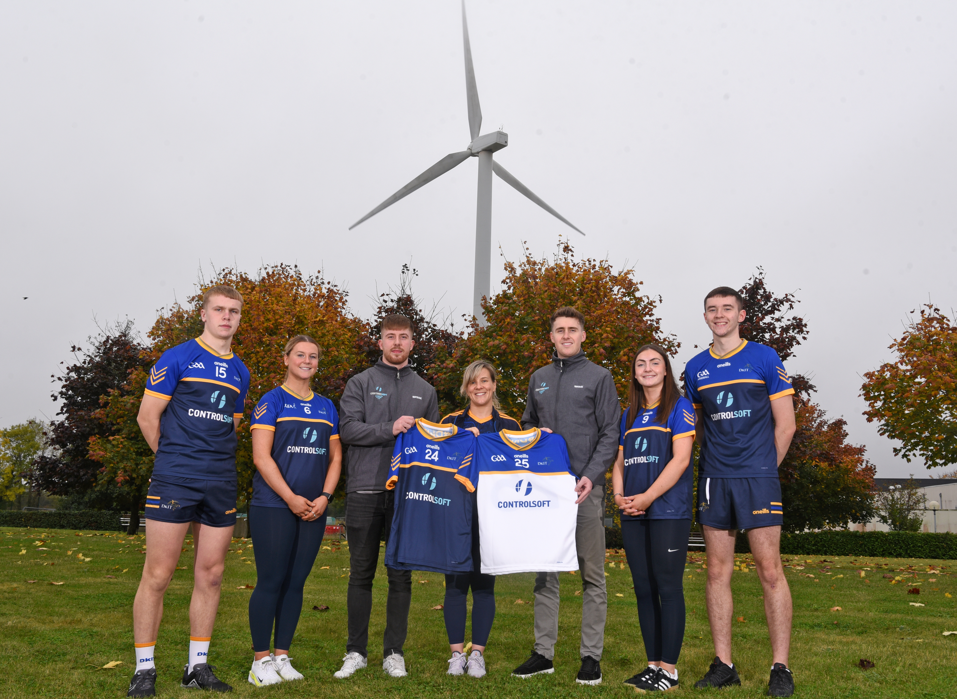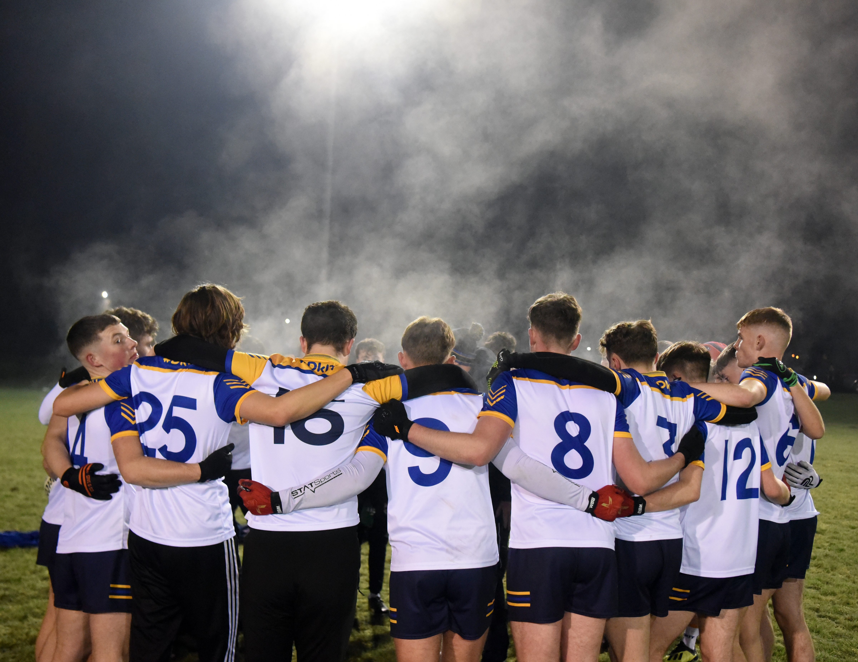

Knockbridge native and DkIT graduate Brian Óg Corr replaced Bronagh McGrane as Sports and Societies Officer at the end of the academic year. Brian Óg brings over a decade of experience working with Leinster GAA to his new role. A past pupil of the CBS in Dundalk, Brian Óg studied Community Sports Leadership at DkIT, where he was no stranger to the college’s vibrant sports scene.

2.7 Careers & Employability Centre
 | Careers and Employability is DkIT's dedicated careers and enterprise service. We're here to support students and graduates identify their career goals, plan for their future and achieve their full personal and professional potential.

The Careers and Employability Centre (CEC) work with students from first year through to graduation, focusing on career development support and student work placement. The Centre also contributes to the wider employability agenda through industry partnerships, research, resource development, and participation in local and national employability networks

Service Activities and Developments:
The Careers & Employability Centre had a very active 2024/25. The team delivered a wide range of student-centered and employability-focused services and initiatives. Events were tailored to student requests and employer interests, building on bespoke employability events piloted in the previous year.

Annual Careers Fair
The flagship Annual Careers Fair took place in October 2024, welcoming over 70 companies to campus. The event was sponsored by Kingspan and featured a wide spectrum of local, regional and national employers. The fair served as a key opportunity for students to explore career pathways aligned with their fields of study.

School-Specific Careers Events
A total of eight themed career events were held on campus, developed in partnership with academic schools and programmes. Two events received financial support from N-TUTORR, which significantly boosted participation and engagement.
- Nursing & Midwifery Careers Event – 20 November 2024
- Careers & Teaching Event – November 2024
- Creative Careers Event – 23 October 2024
- Business & Humanities Careers Event – 20 March 2025
- Engineering Futures Careers Event – 26 March 2025
These events were tailored in response to student and employer surveys calling for discipline-specific engagement. Feedback was overwhelmingly positive, with increased visibility of career pathways and stronger links between academic study and industry.

Employability Series: Skills for Success
The Centre delivered a six-week Employability Series designed to enhance student career readiness. Sessions were facilitated by both external consultants and members of the Careers & Employability team, covering a range of practical topics:
- Creating a LinkedIn profile with impact
- Postgraduate pathways to teaching
- Careers/CV workshop for tech students
- Stand Out Strong – Confidence & self-promotion for interviews
- Employability for international students – navigating visas and work permits
- Crafting a winning CV
Supported by N-TUTORR, this series reflected the Centre’s commitment to equipping students with the skills needed to thrive in a rapidly evolving job market, including sectors impacted by AI and digital transformation.

Student Support Hub on Moodle
The Moodle Student Support Hub continues to serve as the central repository for all careers information, resources, and templates. The extensive Career Toolkit is updated annually to reflect ongoing developments in employability skills support.
Our key portals and tools—DkIT Careers Connect, Shortlist Me (video interview practice), and Profiling for Success (psychometric testing)—are all accessible via Moodle, ensuring students have 24/7 access to career development resources.

Student Work Placements 2024/2025
A total of 653 students across 36 undergraduate programmes were placed during the academic year.
- School of Health & Science: 241 students (36.9%)
- School of Informatics & Creative Arts: 159 students (24.3%)
- School of Engineering: 132 students (20.2%)
- School of Business & Humanities: 121 students (18.5%)

Placement Numbers and Trends (2018–2025)
The Careers & Employability Centre continues to monitor and report on student placement activity across all academic schools at DkIT. The following summary outlines placement trends over the past seven academic years, highlighting both growth areas and emerging challenges.
In the 2024–2025 academic year, a total of 653 students across 36 undergraduate programmes were placed. This marks a decrease from 745 placements in 2023–2024 and 803 placements in 2021–2022 which was the highest recorded in the seven-year period.
School | 24-25 | 23-24 | 22-23 | 21–22 | 20–21 | 19–20 | 18–19
School of Health and Science | 241 | 287 | 277 | 316 | 303 | 297 | 278
School of Informatics and Creative Arts | 159 | 126 | 104 | 137 | 69 | 98 | 95
School of Business and Humanities | 121 | 203 | 205 | 227 | 222 | 267 | 282
School of Engineering | 132 | 129 | 124 | 123 | 122 | 64 | 87
Total Placements | 653 | 745 | 710 | 803 | 716 | 726 | 742

The decline in placement numbers in 2024–2025 is primarily due to reduced student enrolment in several programmes. Factors contributing to this include:
- Smaller graduating cohorts in key disciplines
- Transitional gaps as new programmes await their first placement cycles
- External constraints in sectors such as Nutrition and Health, where placement sites are reserved for Dietitian students
- Alternative modules replacing placement in some programmes
Despite the overall decline, the School of Informatics & Creative Arts and the School of Engineering saw modest increases, reflecting strong industry demand and successful engagement efforts.

Challenges and Developments for 2025/2026
Several new programmes will introduce placement modules in January 2026:
- BA (Hons) Sport and Exercise with Business
- BA (Hons) Digital Marketing and Strategic Communication
- BSc (Hons) Nutrition and Health (no alternative modules)
- BSc Bioscience
- BSc (Hons) Bio Pharmaceutical Science
- BSc Pharmaceutical Science
Securing host sites for these programmes presents a challenge, particularly in sectors where placement capacity is already committed to other institutions. Work is ongoing to identify new opportunities and partnerships.

Engineering Placement Expansion
All Engineering programmes will transition to a 12-week semester placement in 2026, up from the previous 5–8-week model. This change has been welcomed by employers, many of whom already extend student placements beyond the minimum requirement.

Paid vs Non-Paid Placements
The Centre continues to advocate for paid placements across all sectors. However, in some disciplines unpaid placements remain the norm due to accreditation requirements or sector constraints. Students increasingly request flexibility in working hours, allowing them to balance placement with part-time employment. This is feasible in cases where placement hours do not contribute to external accreditation but must be monitored closely to ensure academic integrity.
The Engineering and Built Environment sectors remain the most buoyant in terms of paid placement opportunities.

Staffing Changes
The year was marked by significant leadership transition. The Head of Service departed at the end of March 2025, creating a period of interim management. The incoming manager officially commenced in October 2025 and provided strategic support during the transition while moving from the Examinations Office. Notably, the incoming manager project-managed the Graduate Outcomes Survey 2025, ensuring continuity in this critical institutional process despite the leadership gap.
This period of change required adaptability within the team, and the successful delivery of the GOS demonstrates resilience and commitment to service quality during a challenging staffing transition.

2.8 Update on Planned Objectives identified in Previous Annual Report
This section provides an update on objectives/planned actions as outlined in the previous AR as Improvement and Enhancement Planning (as documented for the reporting period 2023/2024).
Planned objectives (Previous AR) | Update on Status
Responsibility: (all services).  - Update the Student Support Strategy in line with the new Institute Strategic Plan  - Develop marketing and communication Plan | - Strategy not completed and will continue into the next reporting period.  - Work ongoing with marketing and communication.
Responsibility: (Access and Disability Services)  - Develop an Equal Access and Participation Policy  - Develop a Disability Policy  - Develop Reasonable Accommodations and support the DS Students in Placement in collaboration with Careers Centre  - Develop an Access Forum with community groups in the region  - Follow up on recommendations advised in the Accessibility and Sensory Audits and implement improvements where possible.  - Progression of the Autism Friendly Campus Action Plan | - Equal Access and Participation Policy Approved by AC April ’25.  - Disability Policy Developed – currently under consultation pre-approval  - Reasonable Accommodation Policy – currently under consultation  - Regional Access Forum in operation  - Implementation of Recommendations from Audits ongoing  - Autism Friendly Campus Action Plan ongoing
Responsibility: (Careers & Employability)  - Share the annual Graduate Outcomes Survey data with key internal stakeholders via the newly developed online Power Bi Dashboard.  - Support Students registered with the Disability Service with specific career queries | This work is completed and support is ongoing
Responsibility: (Student Counselling Service)  - Increase rates of completion of outcome measures for counselling service evaluation.  - Introduce measures to reduce cancellations and missed appointments with the counselling service. | - Targeting and monitoring of students completing full profile ongoing  - Reminder to students of impact of missed appointments on appointment allocations - ongoing
Responsibility: (Student Health Unit)  - Review location and opening hours of Student Health Unit. | - Opening Hours updated.  - Request submitted to Space Committee regarding location.
Responsibility: (Pastoral Care)  - Create an Interfaith Space.  - Launch DkIT Student Connect – more events for connections. | Completed in the reporting period
Responsibility: (Sports and Societies)  - Enhance activities on offer during lunchtimes for students  - Support the start-up of a neurodivergent society for students  - Install multi-purpose floor in DkIT Sport using sports capital funding | - Completed in the reporting period.  - Neurodivergent society established.  - Floor under development to be completed in next reporting period
Responsibility: (Executive Board)  - Establish an Alumni Steering Group | Not completed – to be submitted to EB for Review

3. Internal Monitoring and Review
Student Services request feedback from service users as part of their annual monitoring activities. Feedback is reviewed on an ongoing basis with service providers and annually as part of the Service Annual Report. Service Providers participate on national committees and review their service in line with national standards and best practice. Work plans and resources are reviewed in line with feedback, best practice, and the Institute’s strategic plan.
The following is a summary of the data from monitoring activities for the individual services for the reporting period 2024/2025:
3.1 Student Support Monitoring
Mature Student Induction Orientation was offered to 128 students, 56 attended. (44%).
Feedback indicated the session was well received and contributed positively to integration and early engagement.

3.2 Disability Service Monitoring
The DkIT Disability Service measures the effectiveness of the Service through student feedback including an Annual Student Survey, academic and support staff collaboration, facilities (Sensory Room and AT Room) usage, retention data, and use of FSD to improve their supports over time.

A student disability survey was issued to 329 students, disappointingly only 30 students completed the survey, however on a positive note, some information was gained including that a new question targeted at 1st years to ascertain how they felt induction was for them, of the 17 new 1st years who completed the survey, all were satisfied with their transition to DkIT and most of them made contact with the DS in advance of starting in DkIT.
A recurring theme from the survey is that Students need more social spaces, more spaces to sit in main reception areas while awaiting transport etc., particularly those with physical or mobility difficulties. They also need empathy and some programme enhancements to make them more inclusive for students with a disability e.g. project, group work, deadlines.

By engaging with, and being a member of the Disability Advisory Workers Network (DAWN), DkIT DS is consistently benchmarking offerings, keeping up to date on legislation and new advances in technology and resources, and best practice to support students with disabilities. DAWN provides a forum for Disability Officers to share expertise, develop knowledge and skills and collaborate on policies and procedures for supporting students with disabilities in higher education. DAWN works towards developing professional standards and best practices for student inclusion and professionalises the role of the Disability Officer. DAWN’s work aims to promote full access and participation in higher education for students and Disability Officers can use DAWN’s expertise and resources to advocate for more resources and inclusive practices within their own institution. The collaboration among all the Disability Officers across HEIs allows the sharing of knowledge and helps strengthen the DS. DAWN also influences the allocation of and criteria for the Fund for Students with Disabilities. Being part of DAWN provides the DS with professional development opportunities, helps establish standards, promotes inclusive education, enables knowledge sharing and gives a collective voice to advocate for and support students with disabilities.

3.3 Student Counselling Service
The following outcomes are drawn from CIAO, a standardised measure of ‘Counselling Impact on Academic Outcomes’ used across colleges in the UK and Ireland. The following table illustrates improvements in academic engagement, and significant reductions in student issues, namely:
- 53% reduction in students wishing to leave DKIT due to their issues
- 63% reduction in stressors impacting on academic life
- 53% reduction in stressors impacting on overall college life

Question | Pre-Counselling | Post-Counselling
To what extent are you considering leaving your course because of your problems? | 121 | 64
To what extent would you say your problems are affecting your study? | 309 | 195
To what extent would you say your problems are affecting your overall experience at university? | 337 | 180
Table results based on responding students highlighting experiences felt “often” or “most of the time”.

A further six questions were asked as part of the post-intervention CIAO measure. Responses to these questions are summarised below, with the adjoining table:
- 77% said that counselling helped them stay in college; 59% stating that counselling was an important or the most significant factor in helping them stay in college.
- 86% said it helped them do better in their academic work; 50% stated that counselling was an important or most significant factor in doing better at their academic work.
- 93% said it had improved their overall experience of college/university; 64% stated that counselling was an important or the most significant factor in helping them improve their college experience.
- 86% said counselling has helped them develop skills that might be useful in obtaining future employment; 72% it was an important or most significant factor.
- 98% said that counselling has improved their self-esteem; 73% it was an important or most significant factor in improving their self - esteem.
- 93% said that counselling had helped them feel more positive about the future; 82% this was an important or most significant factor in feeling more positive about the future.

These figures demonstrate the impact of counselling not just on well-being and self-esteem but on retention and their performance in college, both of which are key factors associated with longer term wellbeing as well as being key performance indicators for the Institute.
Question Text | Not at all % | To a limited extent % | One of many factors % | An important factor % | The most significant factor % | This was not an issue %
To what extent would you say that counselling has helped you to stay at college/university? | 4.55 | 9.09 | 9.09 | 34.09 | 25.0 | 18.18
To what extent would you say that counselling has helped you to do better at your academic work? | 4.55 | 11.36 | 25.0 | 36.36 | 13.64 | 9.09
To what extent would you say that counselling has improved your overall experience of college/university? | 4.55 | 4.55 | 25.0 | 40.91 | 22.73 | 2.27
To what extent would you say counselling has helped you develop skills that might be useful in obtaining future employment (eg self-understanding, understanding of others, managing difficult feelings better, improving communication skills, increased confidence, assertiveness)? | 4.55 | 6.82 | 6.82 | 45.45 | 27.27 | 9.09
To what extent would you say counselling has improved your self-esteem (how you feel about yourself)? | 2.27 | 11.36 | 13.64 | 38.64 | 34.09 | 0.0
To what extent would say that counselling has helped you feel more positive about the future? | 2.27 | 0.0 | 11.36 | 50.0 | 31.82 | 4.55

Additional services usage

Togetherall data
The recorded data from this service for September to May for academic year of 2024/25 is as follows:
- Total new registrations: 54
- Total active members (e.g.): 29
- Gender: 76% female, 21% male, 3% trans/non-binary.
- Ethnic Background: 32%
- Clinical 1:1 support: 12 episodes of intervention to de-escalate risk or concern
- Emergency action/referral (student contacted due to escalation of risk and referred as required): 1 student.
- Number of screeners/assessments completed: 51
- Top 3 assessments/assessments engaged in: anxiety, depression, emotions.
- Number of courses engaged in: 14 (2 completed)
- Top 3 courses engaged in: Managing Depression & Low Mood, Managing Emotions, and Managing PTSD.
- Average activities per student (chat/assessment/course): 38
- Top 3 themes in chat/expression: Relationships, Anxiety, Depression.
- Breakdown of activity times: Daytime (9-5): 40%, Evening (5pm to 9pm): 30%, Night (12am to 9am): 10%, Weekend: 20%.
NiteLine data
The recorded data from this service for the last academic year noted that DkITstudents:
- Consisted of 2.5% of the national (11 HEIs) 778 support contacts made (The co-ordinator noted that the service may not be able to pinpoint which HEI is the student coming from).
- Most common call topics among DkITcallers were (1) general mental health and (2) romantic relationships.
- Consisted of 47% of callers identifying as female; 52% identifying as male; and 1% identifying as non-binary.

Text About It-Spunout (50808) data
DKIT had 4 student contacts during the last academic year. National data showed that February and October are spikes in service use; with top issues being: College, Anxiety, Stress, Isolation. 80% of users nationally were between 18 and 25. 43% women and 37% male, with the remainder identifying as non-binary or trans.
3.4 Student Health Unit (SHU)
As part of the SHU’s commitment to continuous improvement, the SHU typically invites service users to complete an anonymous online survey via Microsoft Forms during the academic year. This survey is a valuable tool for evaluating the overall experience and satisfaction of those using our services. Unfortunately, due to changes in administrative support this year, the survey was not conducted. Nonetheless, the unit continued to receive consistent and encouraging verbal feedback from both students and staff, reflecting positively on the quality and accessibility of the service. Plans are in place to reinstate the formal survey process in the upcoming academic year to ensure structured feedback is captured and used to inform service development.
3.5 Sports and Societies
Due to transition of staff, an annual survey was not circulated to members of clubs and societies this year but it is intended to survey students once the new sports and societies administrator is in post.
Setting up a Neurodivergent Society was a target from the previous report and it proved to be hugely successful with the society collecting ‘Best New Society’ at the annual awards night.
In terms of sports performances, DkIT offers a wide range of competitive sports teams and some of the highlights this year were: DkIT Freshers GAA team won the All-Ireland Division 2 Championship. The senior GAA team won the Trench Cup and will play in the prestigious Sigerson Cup in 2025/26. Fiachra O’Dhuill retained his Handball Open title and the athletics team won two National medals with Danny Nugent finishing fourth in the 10,000m championship.
3.6 Careers and Employability (CES) - Graduate Outcomes Survey 2024
The Careers & Employability Centre conducted its Annual Graduate Outcomes Survey (GOS) between June and July 2024. Building on last year’s innovation, the Centre continued to use the interactive MS Power BI dashboard, developed with the support of a DkIT Data Analytics graduate. This dashboard provides dynamic insights into graduate outcomes and remains a valuable resource for quality assurance, programme development, marketing, and employability planning. Further enhancements are planned for 2025/26, including multi-year trend analysis.

Key Findings from GOS 2024 (2023 Cohort)

Overall Outcomes
- 91% of graduates were in employment and/or further study in 2024 (slightly down from 93% in 2023)
- Response rate: 38.7% (440 respondents from 1,137 graduates) (significantly lower than 57.1% in 2023 – this drop should be noted as a limitation)
- Gender split remains consistent: 51% female, 49% male

Employment & Education
- 85% in employment (up from 84% in 2023)
- 7% in further study (down from 9% in 2023)
- Other activities: 8% (up from 2% last year)
- Unemployment: 5%, unchanged from 2023

Salary & Contract Type
- Average salary remains around €30,000
- Largest salary band: €30,000–€35,000 (23%), same as last year
- 77% of contracts are permanent (slightly down from 79% in 2023)
- 16% fixed-term contracts, 4% temporary

Employment Sectors
- Human Health & Social Work: 21% (unchanged)
- Professional, Scientific & Technical Activities: 13% (significant sector presence)
- Financial Services: 11% (same as last year)
- Construction: 12% (up from 10% in 2023)
- Education: 8% (newly highlighted sector)

Employment Location
- 96% employed within Ireland (slightly down from 97%)
- Regional breakdown: 29% Louth, 26% Dublin, 5% Monaghan, 4% Meath (same as last year)

Graduate Reflections
- 67% of graduates would be “Very Likely” or “Likely” to choose the same course again (compared to 59% in 2023 – this is an improvement) Neutral: 14%, Unlikely: 12%, Very Unlikely: 7%

Insights & Commentary
- Employment remains strong at 85%, showing resilience in the graduate labour market despite a slight dip in overall positive outcomes (91% vs 93%).
- Response rate dropped significantly (38.7% vs 57.1%), which may affect representativeness and should be addressed in future surveys.
- Construction sector growth (12% vs 10%) and the prominence of Professional, Scientific & Technical Activities (13%) indicate evolving labour market demands.
- Course satisfaction improved (67% vs 59%), a positive trend that contrasts with the lower response rate.
- Regional employment patterns remain stable

4. Community Engagement and Outreach
DkIT has an important role to play in engaging with the local community and beyond. Some of the Student Services community outreach initiatives for 2024/25 are listed below:
Access – Student Support | - Participated in our Spring Open Evening, welcoming community members to explore available programmes.  - Delivered a presentation to the Pathways Group outlining the supports available post entry. The Pathways programme, delivered in collaboration with Louth Local Development, aims to remove barriers to Higher Education for National Access Plan target groups.  - Member of the DkIT Regional Access Forum – supporting equitable and inclusive access to education across the region by connecting educators and community organisations to identify and address barriers faced by disadvantaged or marginalised learners.
Disability | - Executive Member of the Disability Advisors Working Network (DAWN)  - Member of HEI Festival of Autism Acceptance Committee  - Member of the DARE Review and Appeals Panel, which meets to determine the outcome of appeals to the DARE eligibility outcomes from the CAO. The panel ensures all DARE applicants are treated equally and that published eligibility criteria and screening procedures have been applied fairly and consistently.
Student Counselling | - Membership with PCHEI (Psychological Counsellors in Higher Education Institutes) which offers support, resources, and professional development.  - Staff now chair the PCHEI organisation (fortnightly meetings with PCHEI executive).  - Monthly meetings with Heads of Counselling Services in Ireland.  - Involved in quarterly HEA advisory committee for wellbeing for framework review on HC and MHSP. (This group recently arranged the process of reviewing the MHSP framework and liaised with the National Suicide Research Foundation on a HEI review of suicide postvention and death protocols).  - Connecting for Life (CfL) HSE group consultation held regarding strategic plan. (Connecting for Life is Ireland’s national strategy to reduce suicide. Connecting for Life sets out a vision of an Ireland where fewer lives are lost through suicide, and where communities and individuals are empowered to improve their mental health and wellbeing.)  - Counselling met with Children and Young People’s Services Committees (CYPSC). (CYPSC is a key structure identified by Government to plan and co-ordinate services for children and young people in every county in Ireland. The overall purpose is to improve outcomes for children and young people through local and national interagency working).
Careers & Employability | - CEC continued to represent DkIT on AHECS national forum  - Grad Ireland Careers Fair- CV Clinic Participants
Pastoral Care | - Colaiste Dun Na Ri – attended as part of College Awareness Week  - HeadStart – provided wellbeing session and Graduation
Student Health | - Blood Donation Initiative: In October, we partnered with the Irish Blood Transfusion Service to support a local blood drive near campus. Our efforts helped increase awareness and participation, contributing to a successful turnout for this vital community service.  - The Mental Health Nurse Adviser (MHNA) has worked in close collaboration with GPs, community mental health teams, and specialist services to ensure students had timely access to appropriate care. Significant time was dedicated to coordinating and creating care pathways, as well as supporting students in navigating what can often be a confusing and overwhelming system. This hands-on engagement not only supported individual wellbeing but also strengthened the college’s connections with external mental health services.  - Collaborations with other HEI’s - communication with colleagues through a dedicated third-level nursing WhatsApp group. This ongoing collaboration ensures we stay aligned with best practices in patient care and management and remain informed of emerging trends and developments across the sector.  - Members of the Irish Student Health Association (ISHA), which provides regular educational tutorial sessions and serves as a platform for discussing current events and issues relevant to student health. This membership supports our continued professional development and strengthens our engagement with the wider student health community.
Sports & Societies | - Liaised with 15 schools to provide tours of the sports facilities and sports activities and inform them about sports and societies and sports scholarships (alongside the school liaison officer).  - Hosted fitness testing days for scholarship partners Louth GAA academy squads  - Dundalk 10k run: Over 1000 athletes competed. €5,000 was donated as a result of this event to our charity partner SAFE Castlebellingham (Suicide Awareness for Everyone).  - Lennon Cup All Stars- Hosted the U-18 GAA schools All Star team in conjunction with Louth GAA.  - Rugby Future Stars- Sponsored and hosted U-18 Rugby All-star team for boys and girls. Hosted in conjunction with Leinster Rugby  - Sponsor and hosted the DkIT/FAI Schools North East League All-Stars  - Hub for Leinster Rugby North East Squads  - Sports scholarship open night to inform potential students of the sports scholarship programme  - Sponsorship agreement with Dundalk based company Control Soft who now sponsor the GAA club.  - Liaised with Dundalk Parkrun to ensure safe usage of the walking track for their local event every Saturday which caters for approximately 200 runners/walkers.  - Sports scholarships with Louth GAA, Swords Thunder Basketball, Drogheda Wolves, and Louth LGFA.  - Worked with Louth Mavericks American Football Club and Dundalk Cricket Club to ensure that our students can be accommodated in their clubs as we do not have enough members to have teams at DkIT.  - Had 10 TY students complete their TY work experience as part of the sports and societies office from schools in the North East.

5. Staff, Training and Professional Development
5.1 Staffing
Service | Staffing | Responsibilities
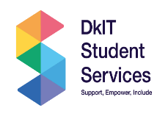 | Linda Murphy Academic Administration & Student Affairs Manager | Management of Admissions, Registration, Fees and Grants, Examinations and Student Services
 | Derek Crilly - Student Services Officer Grade VI | Management of the administration of student services and the strategic planning and operational management of the DkIT Sports and Societies Office.
 | Turlach Cotter/Tanisha Dions - Clerical Officer  Grade III | Student Information Desk, dealing with student queries and admin support for Access.
 | Geraldine Kneel - Disability Officer Grade VI | Co-ordinate and manage the Disability Service for students.
 | Paula Shields - Assistive Technology Officer (PT 20 hrs/week) | Assistive Technology/Student Training on AT
 | Jacqui Ward  Student Support Officer  Grade VI | Management of Student Supports including 1916 Bursaries, Student Assistance Fund, Laptop Loans
 | Patricia Smyth  Student Health Nurse Manager | Manager of Student Health Unit team
 | Judith Bradley  Nurse (0.8 WTE during term) | Nurse in Student Health Unit
 | Naoimh O’Regan  Clerical Officer Grade III | Administrative support to the Health and Counselling Service. Order processing for the Unit
 | Dr Sean O’Connell  Head of Student Counselling Service | Management of Student Counselling Service
 | Melissa Mackin  Student Counsellor (0.8 WTE) | Student Counselling and Mental Health Framework Implementation
 | Sarah Traynor  Student Counsellor (0.6 WTE during term) | Student Counselling and Student Mental Health Framework Implementation
 | Lorna Marie Browne  Student Counsellor (0.6 WTE) | Student Counselling
 | Alan Conlon  Pastoral Care Coordinator | Supporting student wellbeing including their social, physical and spiritual needs.
 | Dr Bronagh Mc Grane  Sports & Societies Officer | Development, promotion and administration of the Sports and Societies Programme and the management of coaches
 | Grainne Laverty  Clerical Officer Grade III | Administration support to the Sports and Societies office
 | Catherine Staunton  Head of Careers & Employability | Manager of the Careers & Employability Centre, the staff and its work programme, resources.
 | Claire Fallon  Employability Advisor | Supports the Careers Development work of the Centre
 | Elaine Cunniffe  Placement Development Co-ordinator | Placement Officer Manager – including staff, placement work programme and internal policy & procedure development
 | Tracey Whately | Placement Development Officer
 | Denise Mc Kettrick | Placement Development Officer
 | Angela Foley | Placement Development Officer
 | Caroline McGee | Placement Development Officer
 | Jacqueline Conlon  Clerical Officer Grade III | Administrative support to Careers and Employability, Disability, Student Finance and the Student Information Desk.

5.2 Training and Development
This section details staff training during the reporting period 2024/2025
Service | Training
Access – Student Support | - N-TUTORR Masterclass – Equality, Diversity & Inclusion - embedding inclusive practice within teaching and institutional culture.  - Introduction to Self-Harm Online Workshop delivered by the HSE - overview of self-harm and practical guidance for supporting individuals.  - Transgender Awareness Training delivery by Transgender Equality Network Ireland (TENI) - understanding of transgender identities and promote inclusive practices in education and community contexts.  - ADHD & Decision-Making: College Course Webinar - this webinar explored how Attention Deficit Hyperactivity Disorder (ADHD) affects decision-making and goal-setting in academic contexts.  - evolved Teaching & Learning Conference – Belonging and Thriving in Higher Education - this event explored strategies for co-creating higher education environments that prioritise well-being, inclusion, integrative learning, and agency. Discussions focused on socially innovative approaches to teaching and institutional transformation.  - SUSI Online Training - key updates relevant to student funding and support.  - Disclosure Training delivered by the Dublin Rape Crisis Centre.  - PDF Accessibility Training, Online Webinar delivering by The National Disability Authority in conjunction with the Irish Computer Society.  - Parent Engagement Training delivered by CampusConnect.
Disability | - DARE review and appeals panel training
Pastoral Care | - European Conference of Student Affairs - attended the European Conference of Student Affairs in Antwerp. This was an excellent opportunity to learn about student issues across Universities in Europe and unique and innovative ideas to address the common issues and improve student life. I then presented my findings and takeaways from the conference to my colleagues at our biweekly Student Services meeting
Student Counselling Service | Training topics were planned and selected as a result of clinician feedback, student data and upcoming developments in the sector:  - Supporting Autistic Students in Higher Education for Student Counselling (AsIam)  - Sensorimotor psychotherapy (PCHEI)  - Creative methods in working with young persons (PCHEI)  - Pornography addiction (PCHEI)  - Classism (PCHEI)  - Online gaming and gambling addiction (PCHEI)  - Domestic violence “In Her Shoes” (DkITRiver Project)  - Working with Student Mental Health (BACP)  Conferences  - Mental Health in Higher Education: Opportunities, Challenges and Supports conference (Maynooth University)  - Trauma informed universities conference (Ulster University)
Careers & Employability Centre | Staff participated in Cappfinity Strengths Profiling training, supported by AHECS (Association of Higher Education Careers Services). This training aimed to enhance the team’s ability to integrate strengths-based approaches into student employability support, aligning with best practice in career development.
Student Health Unit | - HSE Cyber Security Awareness  - Palliative Care Needs Assessment  - Cyber Security Awareness  - Dignity at Work  - Introduction to the National Early Warning System: Nursing Focus  - The Fundamentals of GDPR  - Manual Handling  - AMRIC Hand Hygiene  - Making conversations easier  - Autism awareness training  - Communicating effectively through open disclosure  - Covid -19 Staff health and wellbeing  - Obesity Management in Practice for Health Care Professionals

6 QA Improvement and Enhancement Plans for Upcoming Reporting Period

Supporting the Achievement of Strategic Objectives

This section describes quality assurance and enhancement activities for the upcoming reporting period 2025/2026 which are aligned to the institute’s strategic objectives. The section should be read in conjunction with 2.8: Update on Planned QA Objectives identified in Previous AQR. Actions/activities not completed in reporting period 2024/2025 are carried over to the next reporting period 2025/2026.
Relevant objectives | Planned actions and indicators | Responsibility
Objective 4: To enhance student-centred, practice-based and research-informed inclusive approaches to Teaching, Learning and Assessment which ensures that all students can achieve their potential.  Objective 5: To enhance strong graduate attributes within all our programmes thus fostering the development of globally-minded, work-ready graduates who can contribute sustainably to society. | - Update the Student Support strategy in line with the new Institute Strategic Plan. | Student Services
 | - Improve data collection across all post-entry support services to enable evidence-based planning and reporting | Student Services
 | - Health Service to include BMI, smoking status, and alcohol use alongside vital signs during initial assessments, to support a more holistic approach to student health and early intervention – aid MECC approach  - Mental Health Nurse Advisor to expand group work opportunities and digital technology | Student Health
DKIT counselling data clearly reflects the benefits of attending counselling, bolstering academic performance, wellbeing and retention. Recent international data suggests moving beyond the mental health crisis and providing support and education on the correct forms of signposting to mental health support e.g., appropriate use of assessment, skills, and local services. | - Continue to embed Togetherall, NiteLine, and Spunout as recognised aspects of the Counselling Service.  - Focus on signposting the function of services and strengths/benefits rather than branding.  - In line with MHSP framework and NSRF, complete a suicide postvention policy as part of the student death protocol.  - Complete The JED Foundation program, and become an international JED Campus, with ongoing resources and support. This includes supporting academic staff with their fitness to study policy.  - Support the HEA and National Data Set, alongside PCHEI in their data collection. | Student Counselling Service
The Student Counselling priorities will be influenced by the core service objectives, national directives and learning from our experiences this year | - Offer of 2 drop-in appointments per day.  - Embed clinical services such as groups and campaigns, based on prior training.  - Build and develop frameworks, policies, and related activities e.g. MHSP, JED partnership, DKITstrategic plan, HEA and Department of Health initiatives. | Student Counselling Service
Objective 6: Enhance the lives of our community members by offering a wide range of programmes, access routes and modes of delivery | Strengthen communication campaigns:  - Targeted outreach for all financial supports during inductions  - Develop a dedicated Finance Support Hub on Moodle outlining all available financial supports, with application links for early access  - Collaborate actively with the Student Union and class representatives to disseminate information and establish effective feedback loops.  - Health Service to develop short videos with SU on key topics e.g. Sexual health and screening to encourage engagement and reduce stigma.  - Provide targeted financial assistance and advisory sessions to HEAR eligible students.  - Review promotion of accommodation fund for the next academic year.  - Host an expanded pre-induction programme for mature students to include academic supports.  - Expand workshops to address identified gaps, such as budgeting and financial literacy, in collaboration with external agencies – e.g. Budget Management sessions with MABS | Student Services
 | - Update to the Reasonable Accommodations in Examinations Policy once DAWN network finalises national update.  - Develop Reasonable Accommodations Policy – ongoing – support for students in work placement to be included.  - Progression of the Autism Campus Action Plan. | Disability Service
 | - Implement improvements following SAF process review | Student Support
Objective 15: Promote social responsibility and community involvement across staff and students | - Enhance the activities which are on offer during lunchtimes for students  - Ensure sports clubs and societies contact all sign-ups asap to ensure this is not a barrier to engagement  - provide sports equipment for students to play recreational sports activities on campus | Sports and Societies
Objective 14: Enhanced support for employers and key stakeholders in the region for graduate employment and talent retention | - Establish an Alumni Steering Committee | Executive Board
Objective 21: Enhanced campus facilities and IT infrastructure | Update Facilities:  - Relocation of Health Unit to Ground Floor to improve accessibility and facilitate an isolation space.  - Install a door to the Student Support office space, ensuring GDPR compliance and creating a private, welcoming, and safe environment to enhance student engagement.  - Establish form-filling booths in Student Support Office to assist students with limited digital access  - Complete the installation of the multipurpose floor in DkIT Sport  - Devise a plan to develop outdoor sporting facilities and identify potential funding streams | Executive/Space Allocation

We end this report remembering our friend and colleague Turlach Cotter, whose sudden and tragic death on 15th September 2025 came as a great shock to us all. He was a larger-than-life character who brought humour and an unmistakable spark to Student Services.
He also faced real challenges, and we shared the ups and downs alongside him as a team, as friends. We remember him with smiles, stories, and the many moments of laughter he gave us. He leaves behind a space that cannot quite be filled, and a legacy that will stay with us.
Rest in Peace Turlach!
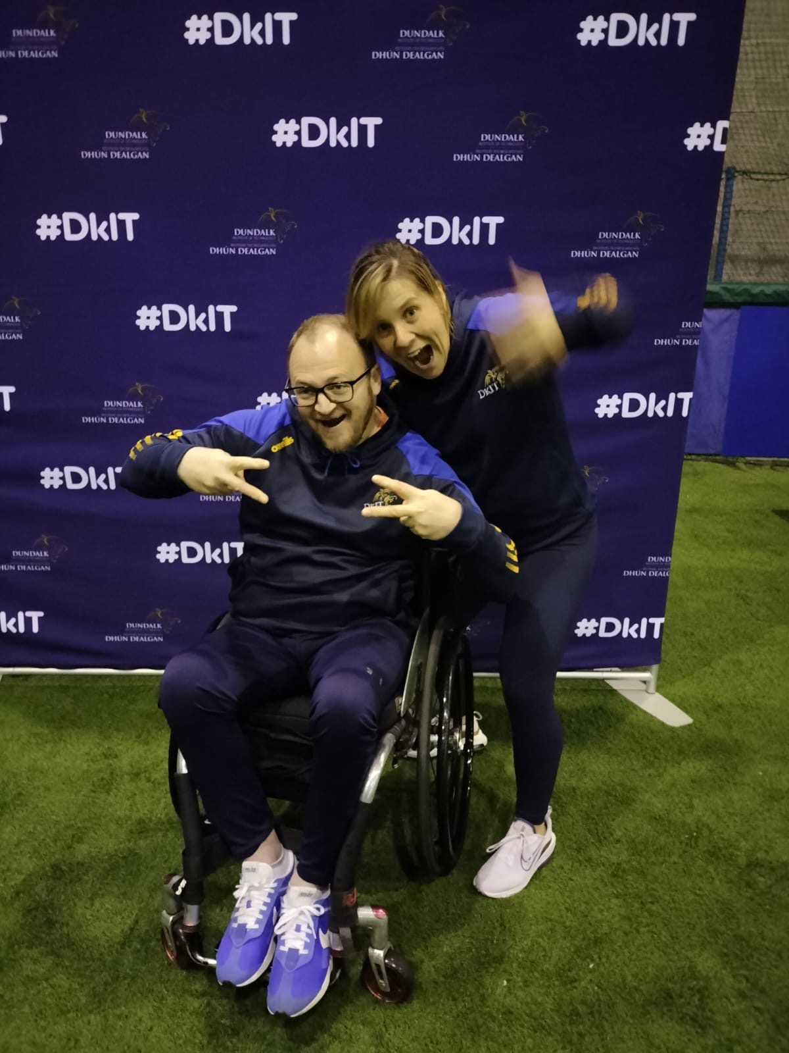
Photo: Turlach Cotter (R.I.P) and Dr Bronagh Mc Grane

