- Log on to the Self Service link https://ssb.dkit.ie/StudentSelfService/

- Enter DkIT username – (this is the same as your email/Moodle login) and NEXT

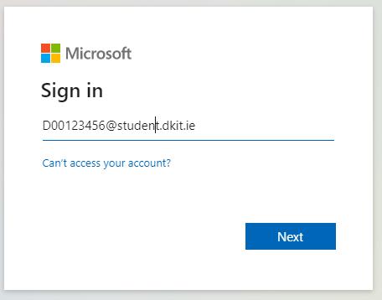

- Enter password for your DkIT Account – Select Login
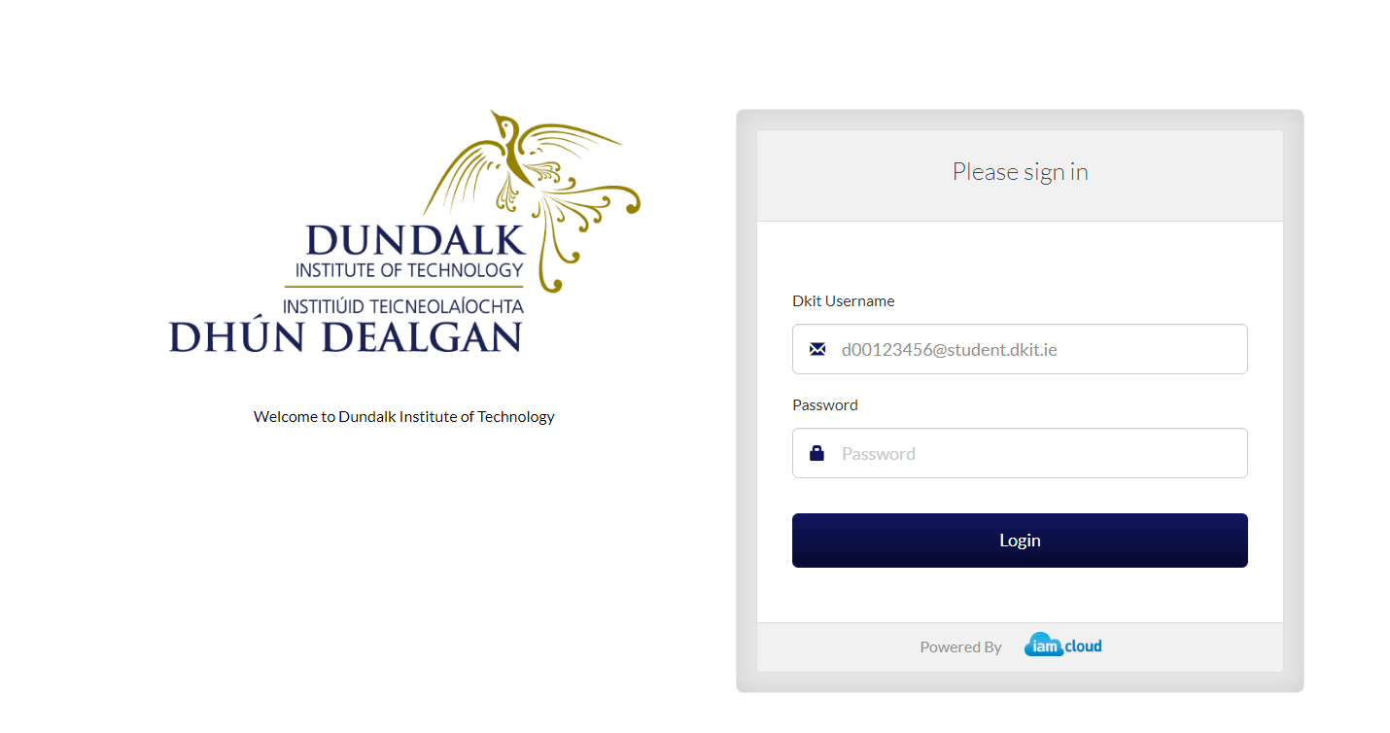

- Select Account Information
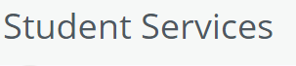
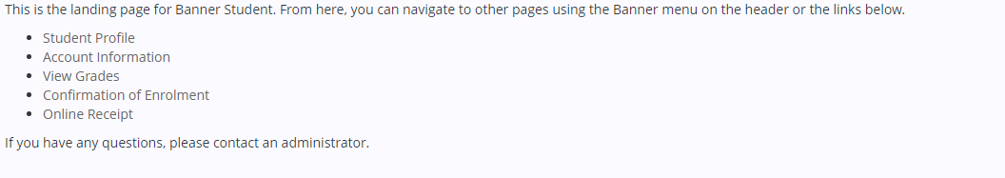
- Select Pay Now
- Balance owed is displayed – enter Pay Now to PAY the Full Balance – or enter the payment amount in the Net Term Balance Field
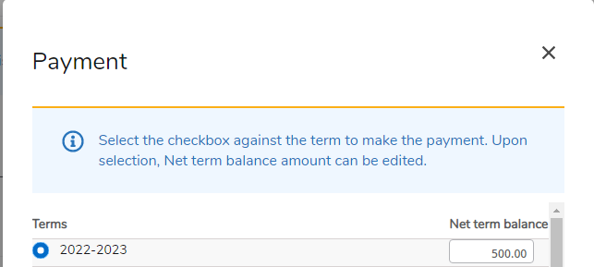

- Select Pay Now
- Complete the Cardholder billing information
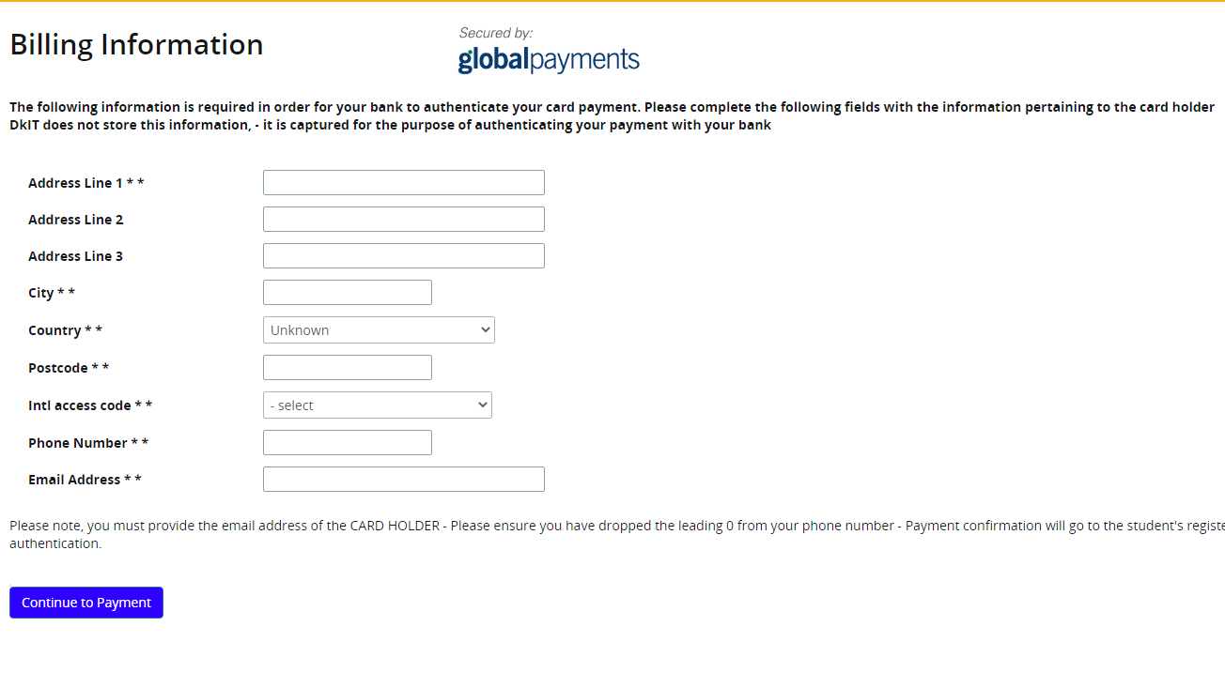
- Enter Card details and Pay NOW
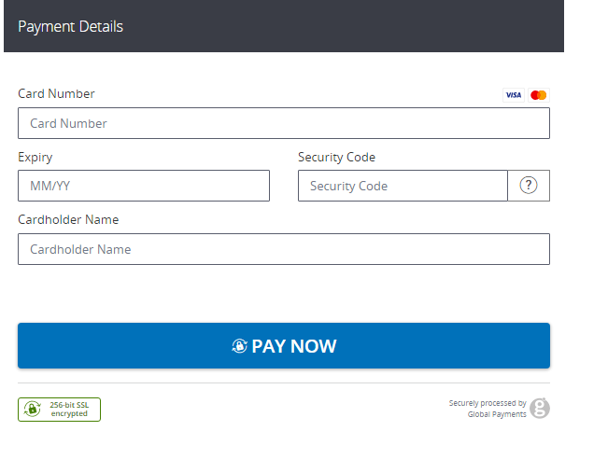
Once Payment is processed –a confirmation email will be sent to your DkIT email address
Navigate back to the home page by selecting this icon on the top left of the screen
Sign out by selecting the icon on the top right of the screen

