DkIT Face Covering Protocol -STUDENTS

- The Institute requires all persons to wear face coverings, in the form of a mask, when indoors in Institute buildings. Face coverings must be worn during when in class, when moving through buildings, in corridors and on stairwells, queuing for any reason, using toilet facilities, when using the library, etc.

- The face coverings must cover the nose and mouth.

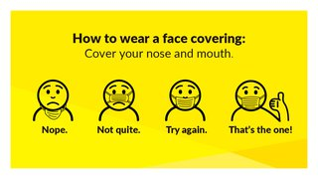

- Unacceptable face coverings include: scarves, bandanas or snoods; face coverings with “direct exhaust valves” and face coverings that are disrespectful and inappropriate for a campus environment or contain an offensive message or image.

- Some students may have a medical exemption from wearing a face covering. If you are in this category you are required to register this with the Disability Service here.

You will be contacted by a member of the Disability Team when your exemption has been processed. A DkIT letter headed note and lanyard can be issued detailing the exemption. If you have this exemption you must where possible maintain 2M distance at all times from other persons while indoors.

- Generally, we expect all persons attending campus to be compliant. The following is the way in which this shall be addressed in the teaching environment:

  - Staff shall remind students at the start of class that they are expected to wear a face covering during class and that it should be covering nose and mouth for the duration of the class.
  - If breaches of face covering wearing occur after class has started the lecturer shall remind students that they must be worn unless they have a medical exemption.
  - If a problem persists continuously the lecturer shall remind students that wearing a face covering is required by DkIT and they may be asked to leave the class which may lead to disciplinary consequences if they do not comply.
  - If there is a continued refusal by a student to wear the mask or leave, the class may be ended and the Head of School informed.

