DkIT Face Covering Protocol -STAFF

- The Institute requires all persons to wear face coverings, in the form of a mask, when indoors in Institute buildings. Teaching staff do not need to wear a mask while teaching, as long as they can remain 2m from the nearest student. Even where mask wearing may not be strictly necessary, staff should continue to wear a mask/visor if it makes them feel more comfortable or safe. PMSS staff do not need to wear a mask while occupying an office with a colleague, as long as they can maintain 2m from colleague.

- The face coverings must cover the nose and mouth.

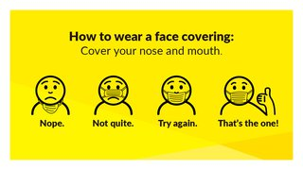

- Unacceptable face coverings include: scarves, bandanas or snoods; face coverings with “direct exhaust valves” and face coverings that are disrespectful and inappropriate for a campus environment or contain an offensive message or image.

- Some students may have a medical exemption from wearing a face covering. If students are in this category they are required to register this with the Disability Service: here . A DkIT letter headed note and lanyard will be issued detailing the exemption. If they have this exemption they must where possible maintain 2M distance at all times from other persons while indoors. Staff who have a medical exemption should notify Human Resources.

- Generally, we expect all persons attending campus to be compliant and staff are not required to enforce mask wearing.

- However, the following is proposed as a way to address this in the teaching environment:
  - Remind students at the start of class that they are expected to wear a face covering during class and that it should be covering nose and mouth for the duration of the class.
  - If breaches of face covering wearing occur after class has started remind students that they must be worn unless they have a medical exemption.
  - If a problem persists continuously, remind students that wearing a face covering is required by DkIT and they may be asked to leave the class which may lead to disciplinary consequences if they do not comply.
  - If there is a continued refusal by a student to wear the mask or leave, the class may be ended and the Head of School informed.

